

VIT BHOPAL UNIVERSITY
School of Computing Science and Engineering
Bhopal-Indore Highway, Kothrikalan, Sehore
Madhya Pradesh - 466114

CSE3016 – AWS SOLUTION ARCHITECT

REG.NO : 23BAI10917
NAME : Vijay Rajesh R
BRANCH : AIML
SEMESTER: INTERIM SEMESTER 2025-26

INDEX

Ex.No | DATE | EXPERIMENT NAME | PAGE NO.
 | 10-11-25 | Launch an EC2 instance using the AWS Management Console and deploy a website using Apache middle ware. | 03
 | 11-11-25 | Deploy a static website in S3 and manage the website using S3 life cycle management. | 10
 | 12-11-25 | Creating DNS records, configuring routing policies, implementing health checks, and monitoring DNS health using Route 53. | 14
 | 13-11-25 | Create and configure Amazon Elastic File System (EFS) to create scalable and shared file storage for AWS resources and EFS file system, mount it to EC2 instances, and configure access permissions. | 20
 | 13-11-25 | Create and configure CloudFront distributions to accelerate the delivery of their web content, improve website performance, and enhance user experience. | 24
 | 14-11-25 | Create AWS Certificate Manager (ACM) for managing SSL/TLS certificates for secure communication in AWS. | 29
 | 14-11-25 | Create and manage customer master keys (CMKs), encrypt data using KMS, and integrate KMS with AWS services for encryption. | 33
 | 14-11-25 | Set up CloudWatch monitoring for AWS resources, create custom metrics and alarms, analyze logs, and troubleshoot performance issues using CloudWatch. | 41

EXP.NO: 01 | Launch an EC2 instance using the AWS Management Console and deploy a website using Apache  middle ware
DATE: 10-11-25

AIM

To Launch an EC2 instance using the AWS Management Console and to successfully deploy a website using Apache middle ware

PROCEDURE

- Launch EC2 Instance: Use the AWS Console to launch a t2.micro instance with Amazon Linux 2023 and an appropriate Key Pair.

- Configure Security Group: Ensure the instance's Security Group allows inbound traffic on Port 22 (SSH) and Port 80 (HTTP).

- Connect via SSH: Use your downloaded .pem key file to SSH into the instance using the public IP address.

- Install Apache: Run sudo dnf update -y then sudo dnf install httpd -y on the instance.

- Start and Enable Service: Run sudo systemctl start httpd and sudo systemctl enable httpd.

- Deploy Website: Navigate to /var/www/html/ and create or upload your website files (e.g., sudo nano index.html).

- Test: Open the instance's Public IPv4 Address in a web browser to view the deployed website.

IMPLEMENTATION SCREENSHOT

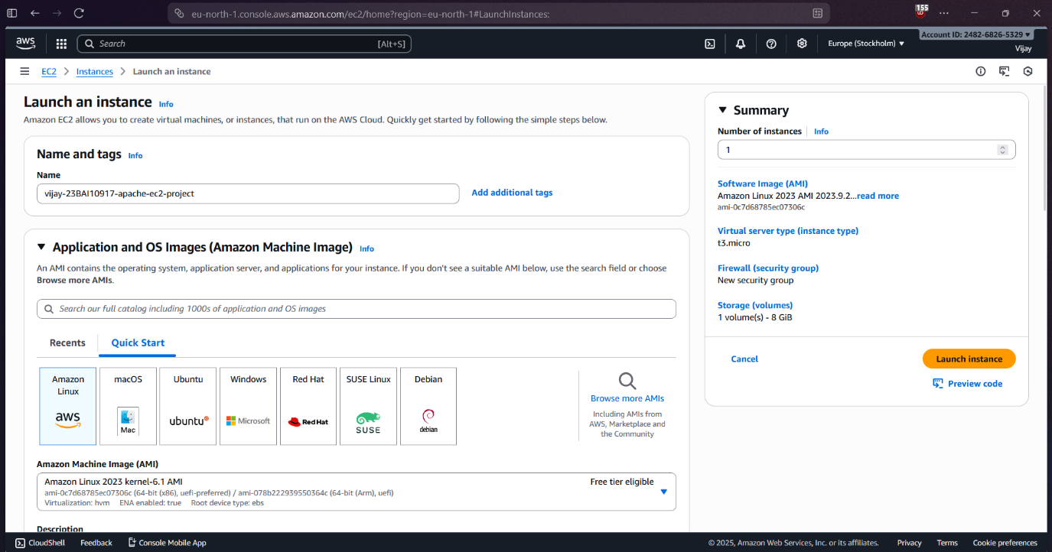

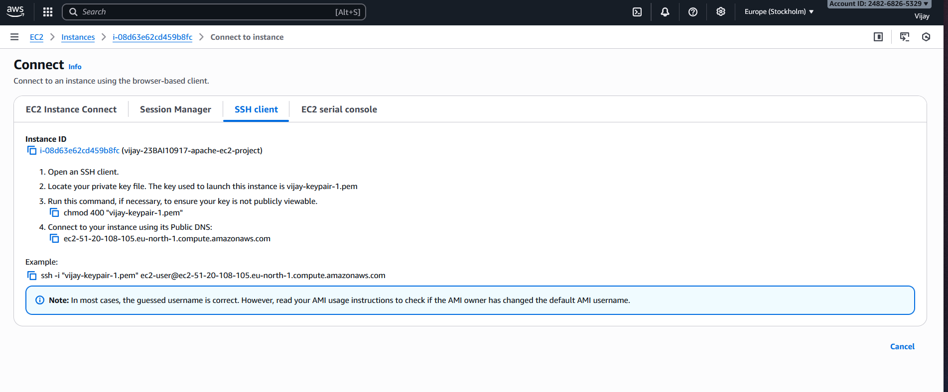

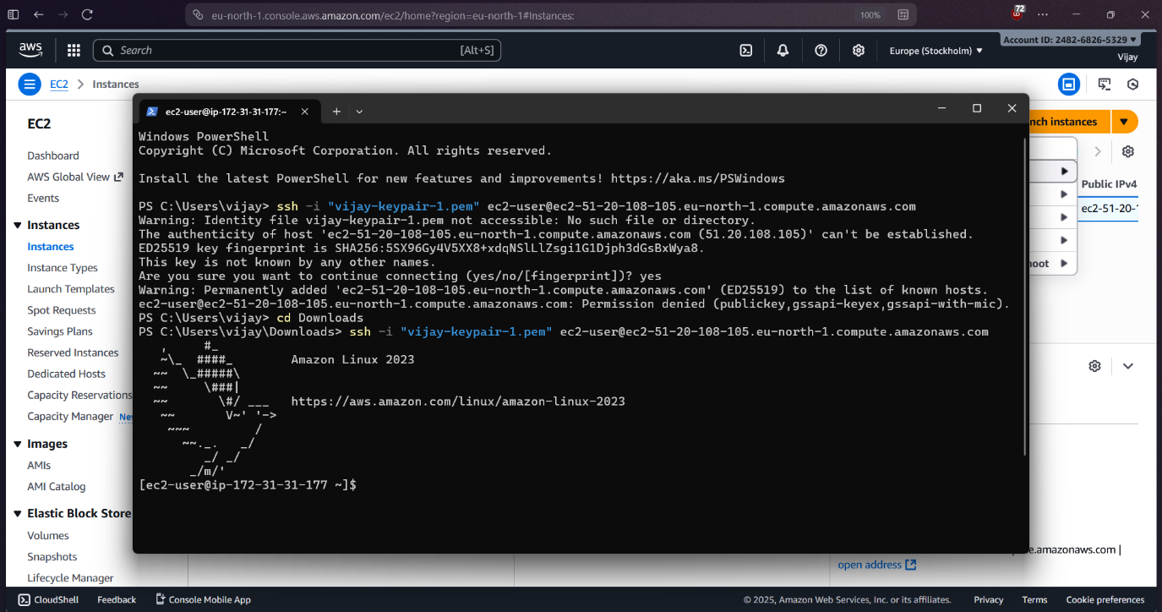

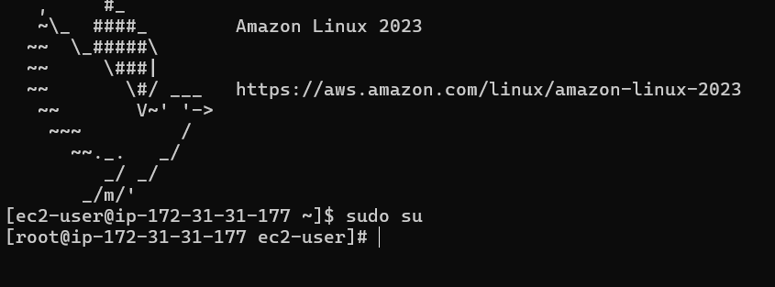

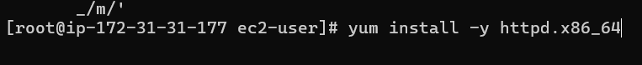

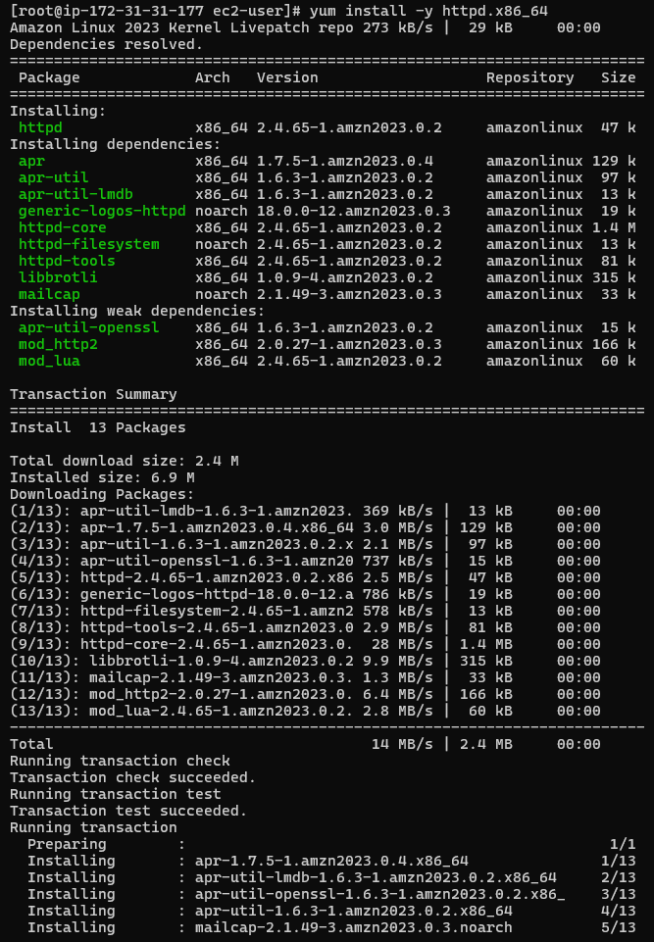

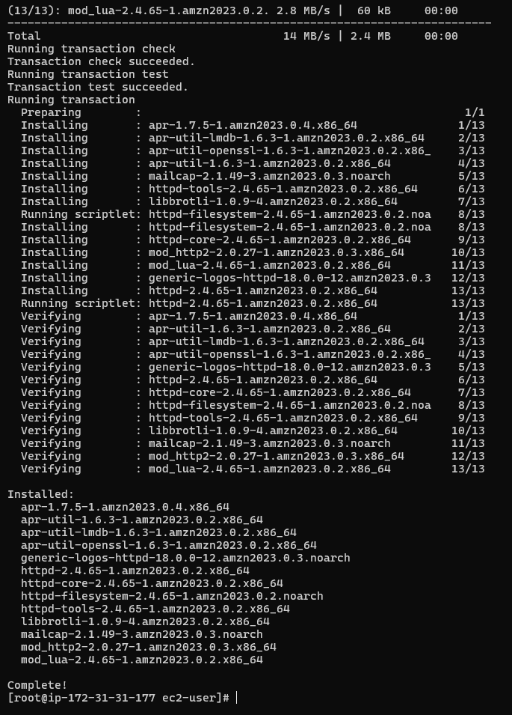

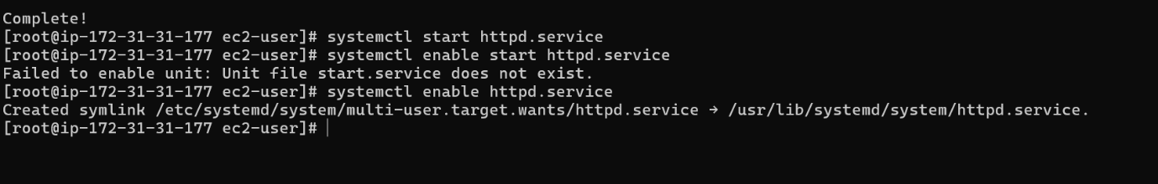

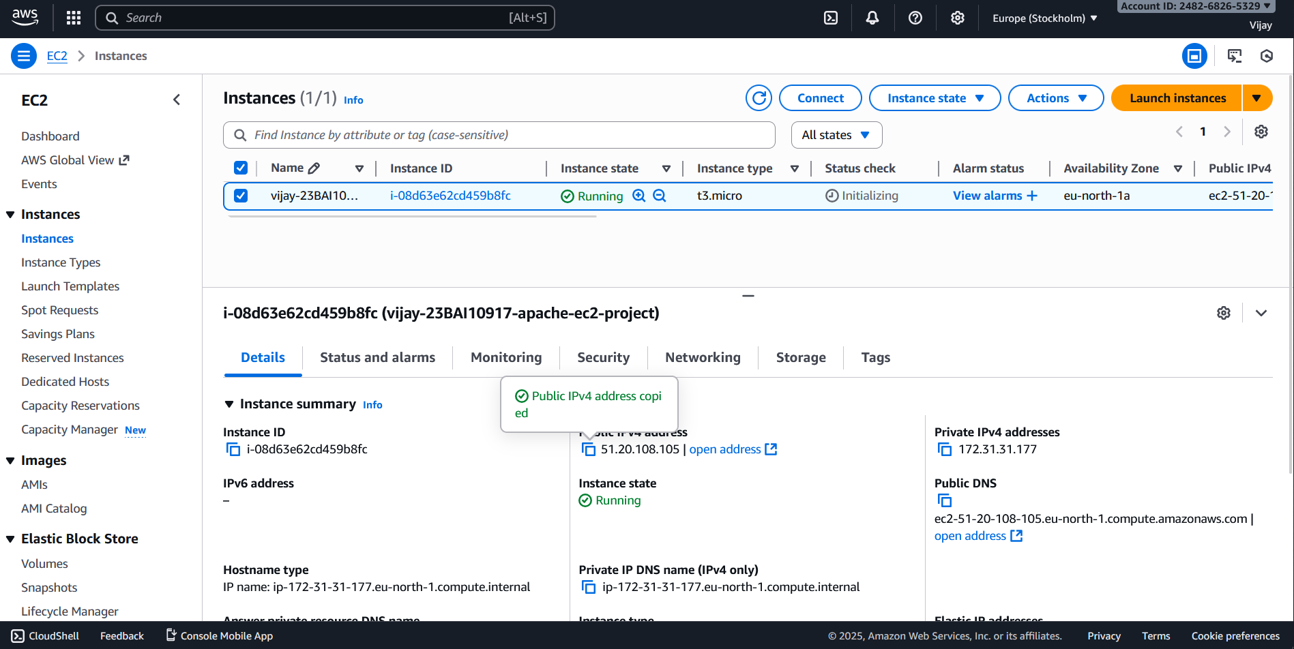

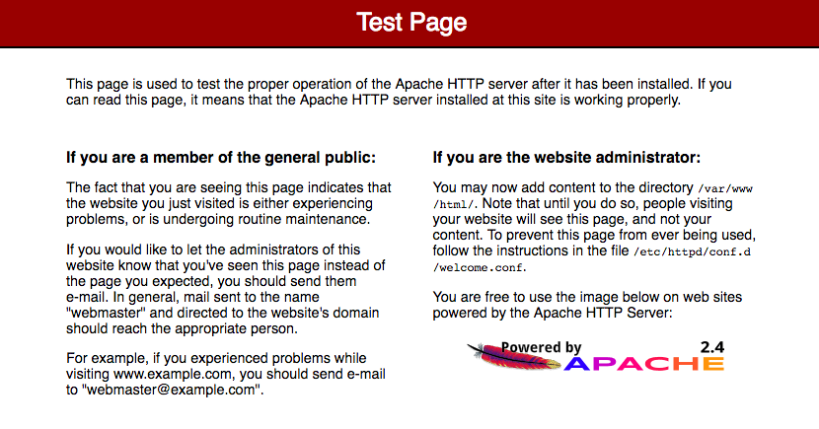

RESULT

Thus, EC2 instance has been launched using the AWS Management Console and a website is deployed using the Apache Middle ware

EXP.NO: 02 | Deploy a static website in S3 and manage the website using S3 life cycle management
DATE: 11-11-25

AIM

To deploy a static website in S3 and manage the website using S3 Life Cycle Management, in the AWS Management Console

PROCEDURE

Step 1: Create and Configure the S3 Bucket

- Create Bucket: In the AWS S3 Console, click "Create bucket". Give it a globally unique name (e.g., my-static-site).

- Public Access: Uncheck "Block all public access" during creation (you'll set permissions next).

- Enable Website Hosting: Go to the bucket's Properties tab, find Static website hosting, click "Edit", select "Enable", and specify your Index document (e.g., index.html) and Error document (e.g., error.html). Save changes.

Step 2: Upload Files and Set Permissions

- Upload Content: Go to the Objects tab and Upload all your website files (HTML, CSS, images).

- Apply Bucket Policy: Go to the Permissions tab and click "Edit" under Bucket Policy. Paste a policy granting public s3:GetObject access to all resources in your bucket, replacing YOUR_BUCKET_NAME. Save changes.

- Test Access: Paste the Bucket website endpoint (found under Properties) into a browser to confirm the site is live.

- Step 3: Implement Lifecycle Management
- Create Rule: Go to the Management tab, find Lifecycle rules, and click "Create lifecycle rule".

- Define Scope: Give the rule a name (e.g., Archive-and-Expire) and choose "Apply to all objects" or use a prefix (e.g., backups/) to target specific folders.

- Configure Transitions (Cost Optimization): Check "Transition current versions of objects...".

- Click "Add transition": Move objects to Standard-IA after 30 days.

- Click "Add transition": Move objects to Glacier Instant Retrieval after 90 days.

- Configure Expiration (Cleanup): Check "Expire current versions of objects" and set the number of days after creation (e.g., 365 days) to permanently delete the objects.

- Finalize: Click "Create rule". The lifecycle rule will now automatically manage the storage class and eventual deletion of your objects based on their age.

IMPLEMENTATION SCREENSHOT

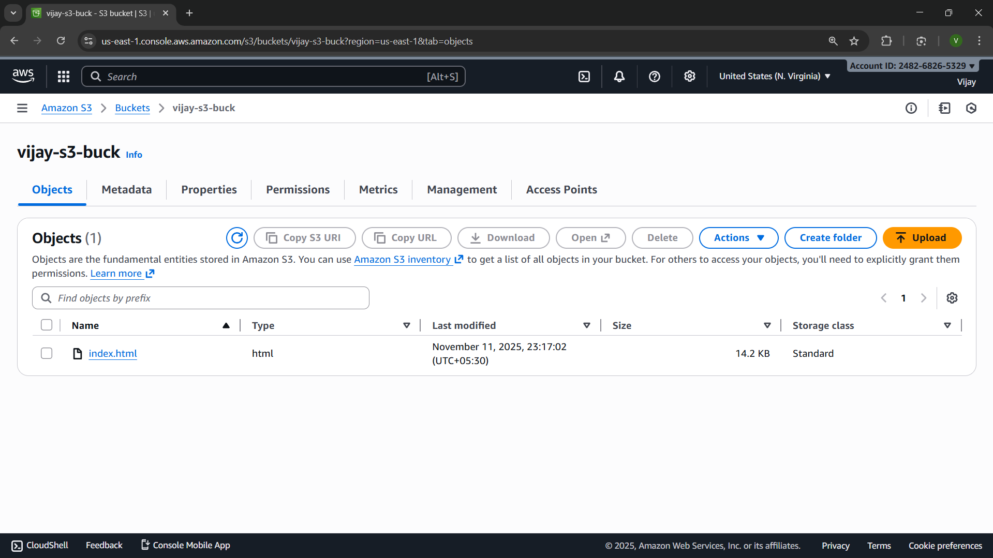

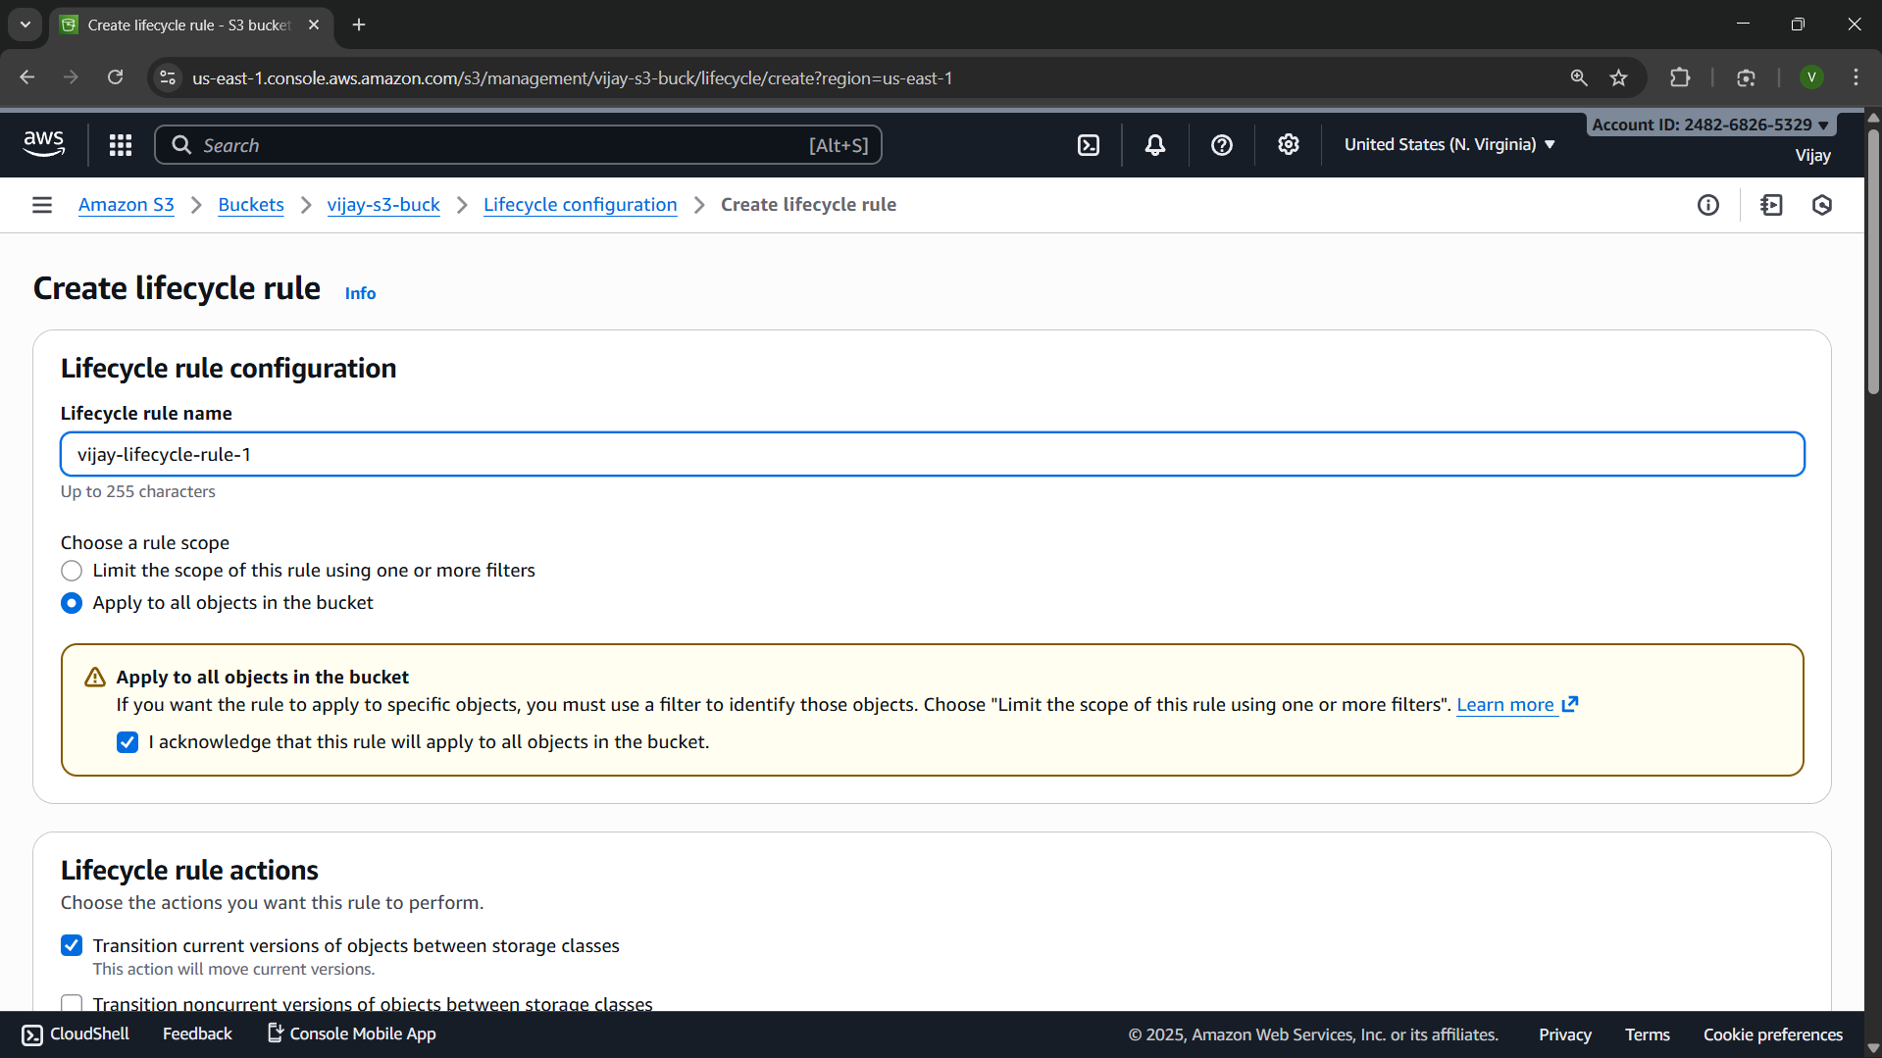

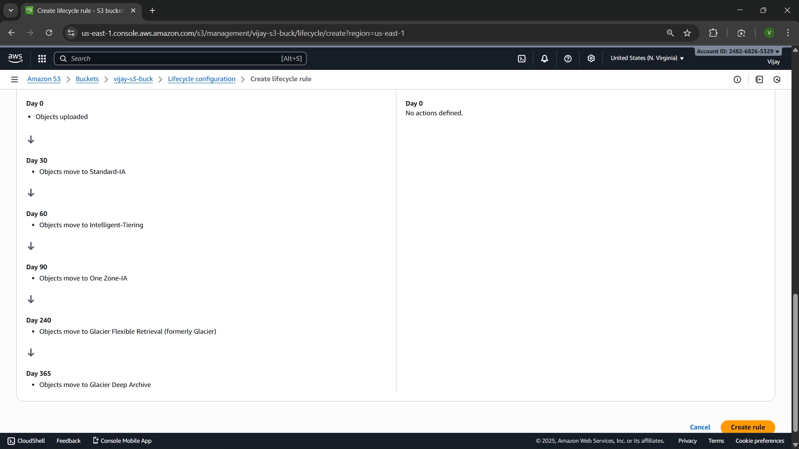

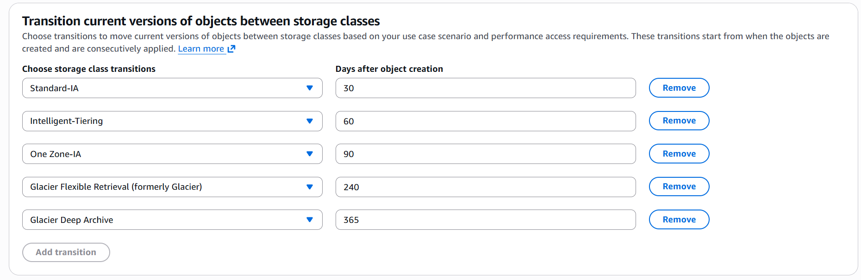

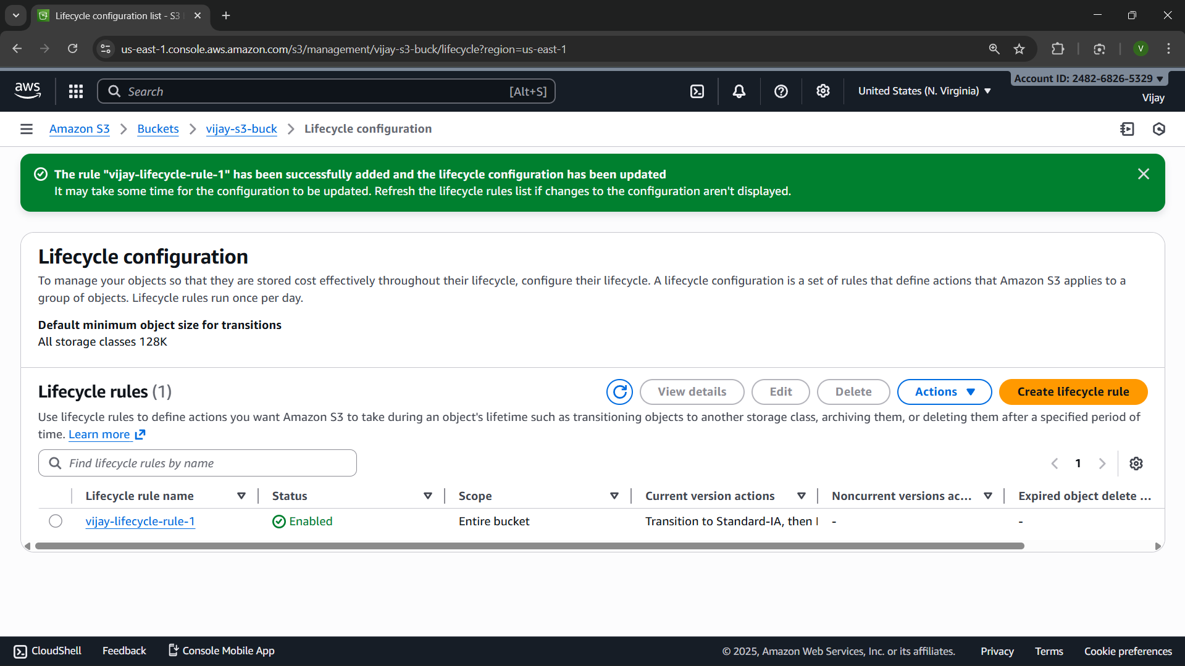

RESULT

Thus, a static website is deployed in S3 and it is managed using S3 life cycle management.

EXP.NO: 03 | Creating DNS records, configuring routing policies, implementing health checks, and monitoring DNS  health using Route 53
DATE: 12-11-25

AIM

To establish a low-latency, and highly available Domain Name System (DNS) architecture for a web application using AWS Route 53, including the configuration of various routing policies, implementation of active health checks for continuous resource monitoring, and integration with CloudWatch for automated DNS health monitoring and alerting capabilities.

PROCEDURE

- Create Hosted Zone: In Route 53, create a Public Hosted Zone for your domain (example.com).

- Create Resource Records: Create an A record (or CNAME/ALIAS) pointing to your resource (e.g., EC2/Load Balancer IP). Set the Routing Policy (e.g., Simple or Failover).

- Implement Health Check: Create a Health Check to monitor your endpoint (IP address, domain, port, and protocol, e.g., HTTP on port 80).

- Configure Routing: For Failover or Weighted routing, edit the resource record and associate it with the new Health Check.

- Set Monitoring/Alerts: Select the Health Check and create a CloudWatch Alarm (e.g., using the HealthCheckStatus metric) to send an SNS notification if the status becomes Unhealthy.

IMPLEMENTATION SCREENSHOT

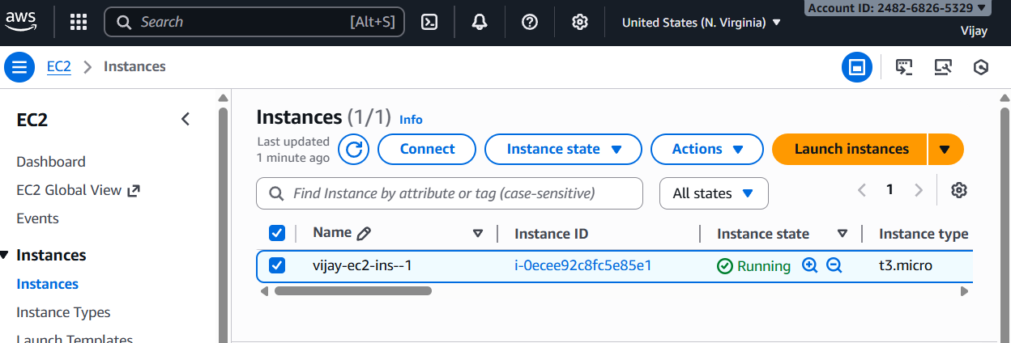

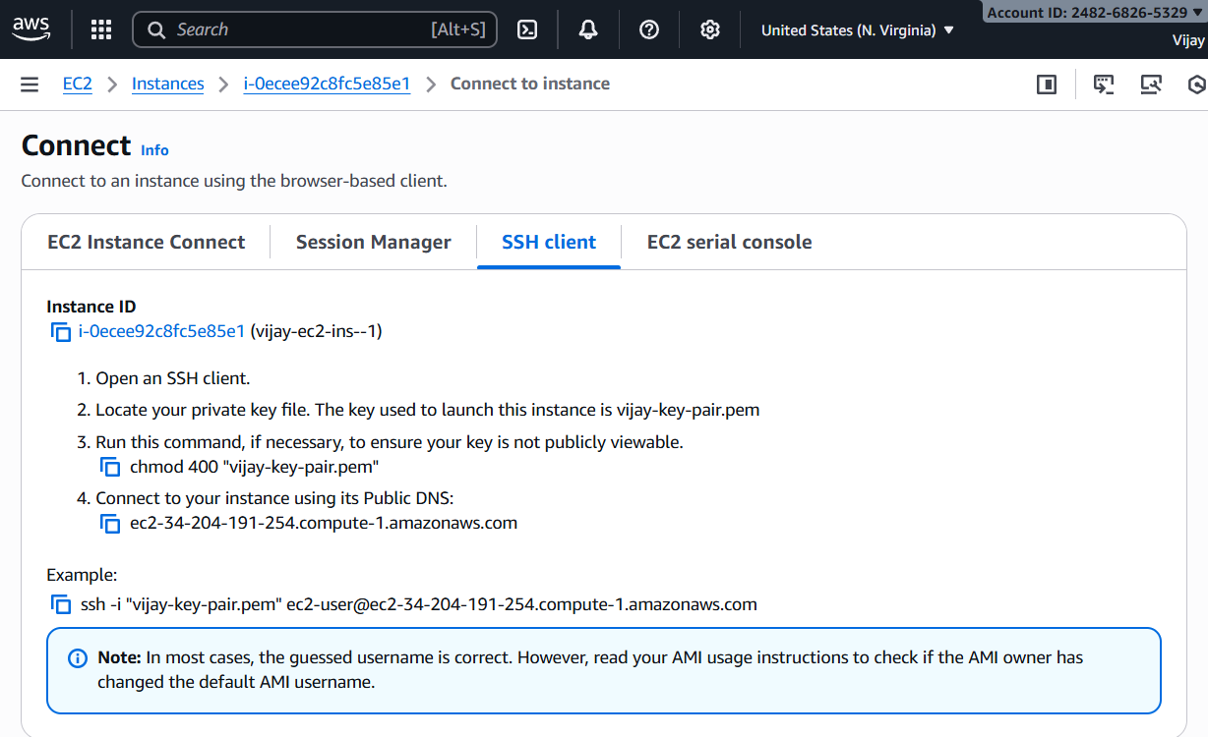
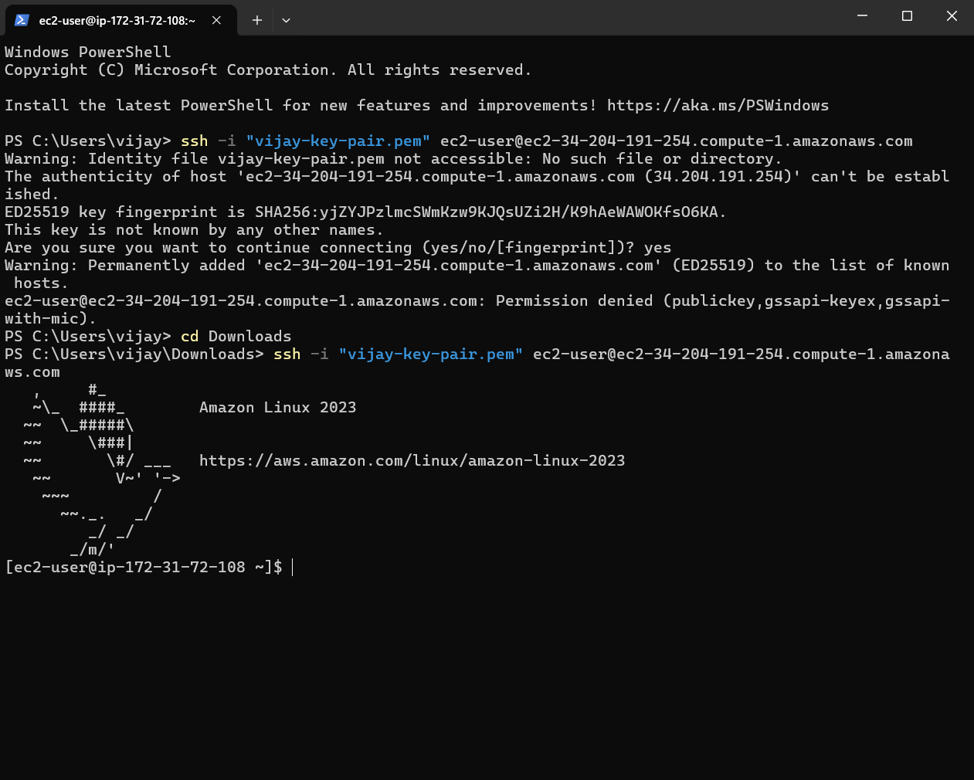

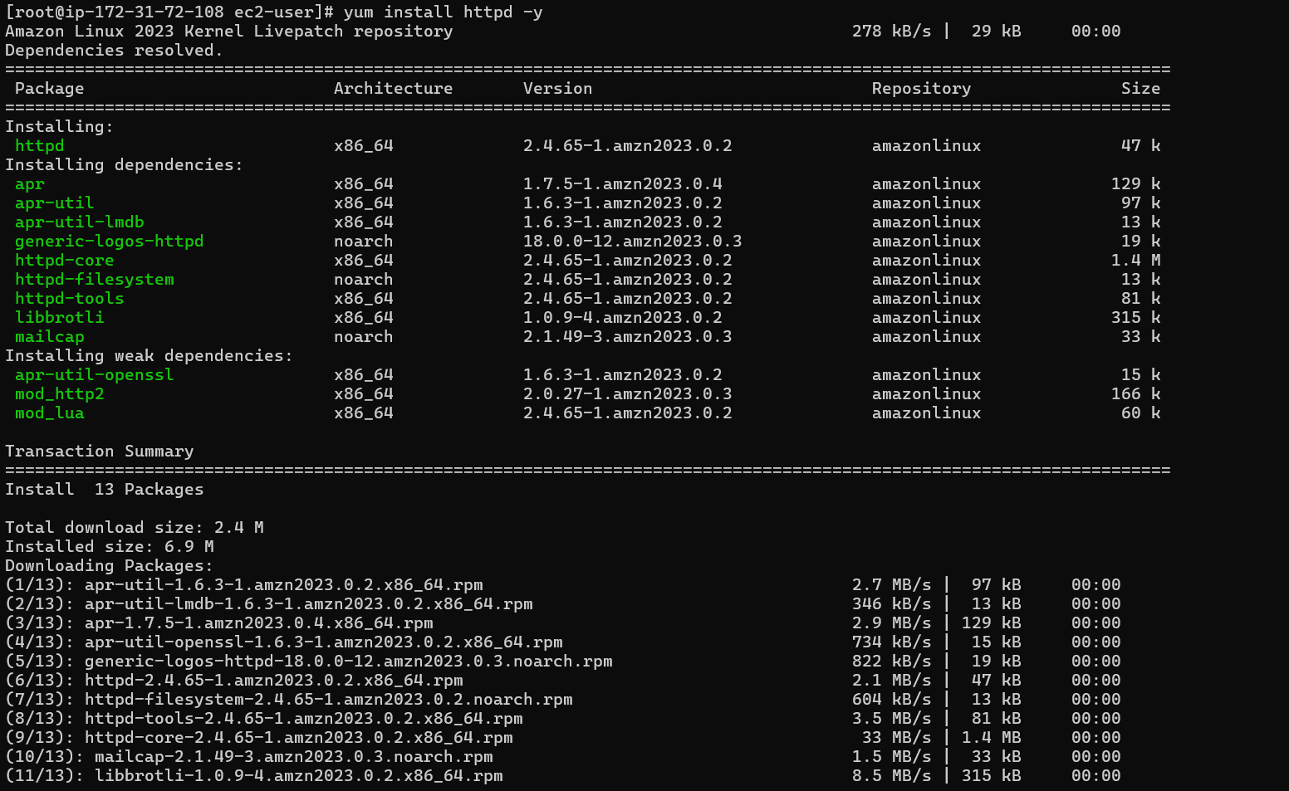

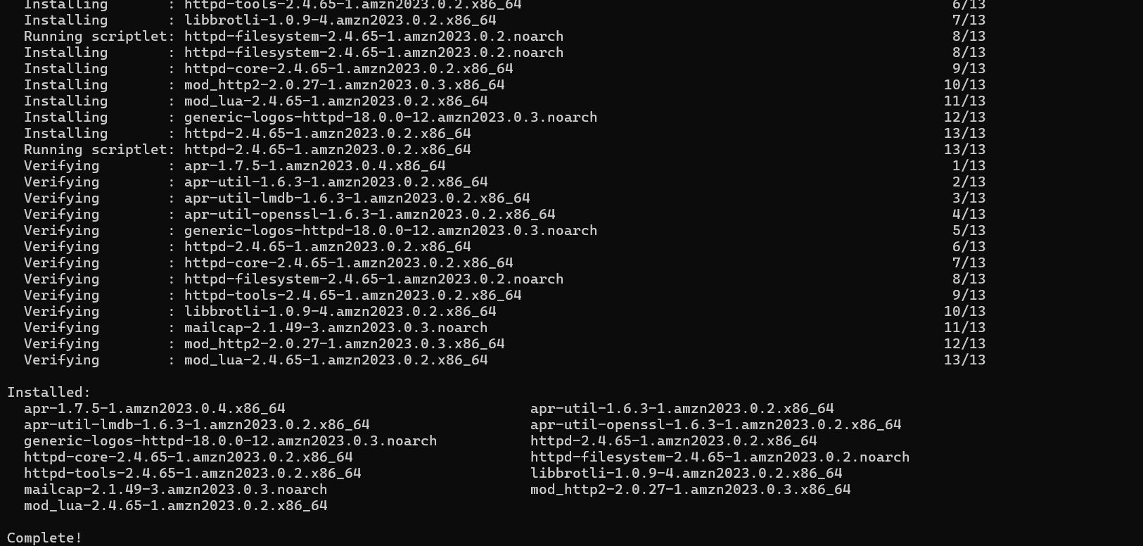

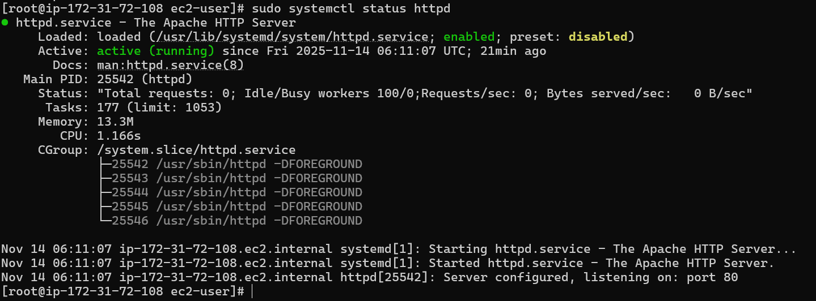

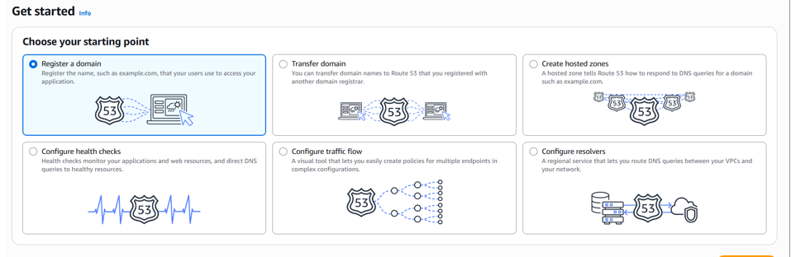

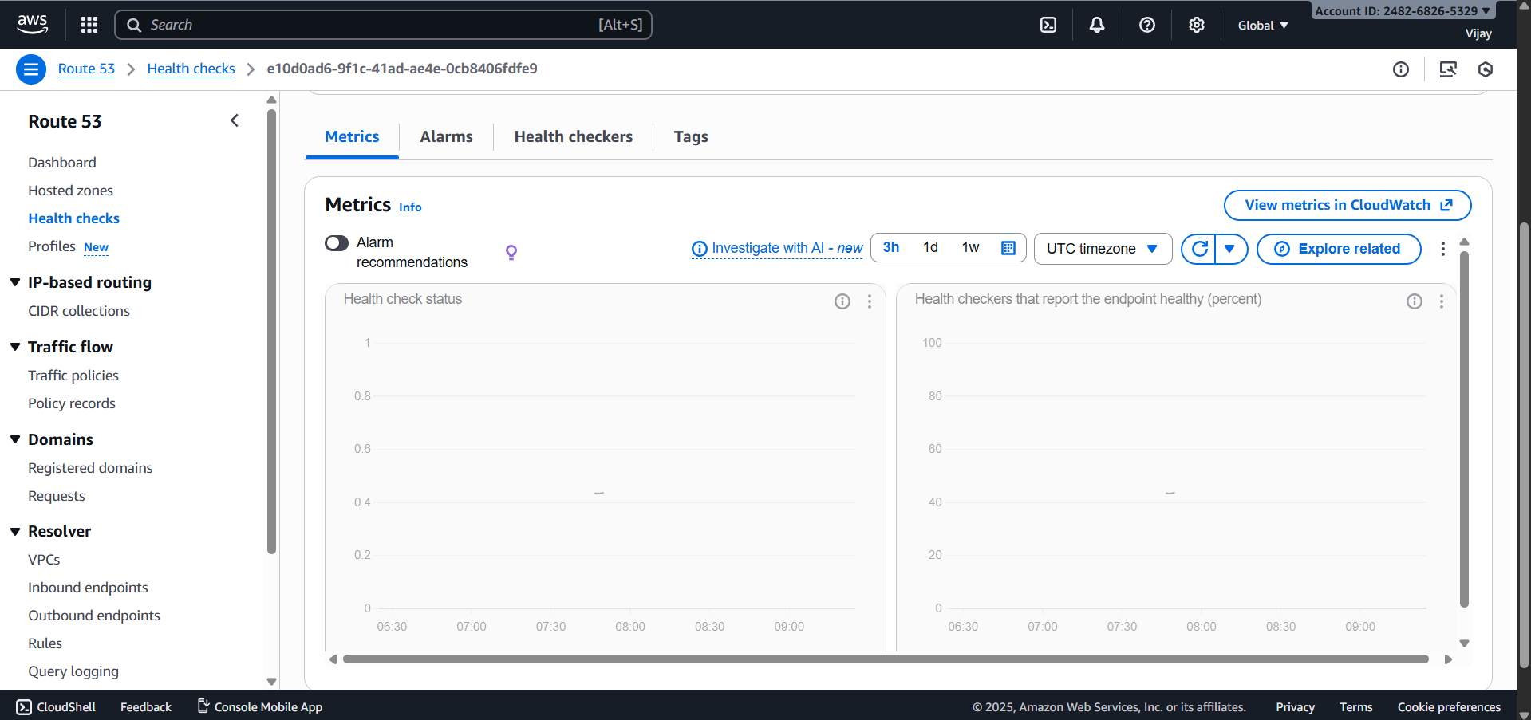

RESULT

Thus, successfully deployed and configured is a foundational web infrastructure: a dynamic EC2/Apache server is operational alongside a scalable, cost-optimized S3 static hosting platform, all centrally managed by AWS Route 53 which provides the domain name, intelligent routing policies, and proactive health checks to ensure high availability and automated failover capabilities while S3 Lifecycle Management optimizes storage costs.

EXP.NO: 04 | Create and configure Amazon Elastic File System (EFS) to create scalable and shared file storage for  AWS resources and EFS file system, mount it to EC2 instances, and configure access permissions
DATE: 13-11-25

AIM

To successfully create, configure, and securely mount an Amazon Elastic File System (EFS) file system onto one or more Amazon EC2 (Linux) instances within the same Virtual Private Cloud (VPC), thereby establishing a highly available, scalable, and shared network file storage solution for distributed applications. The aim also includes setting up access control using Security Groups and, optionally, EFS Access Points and IAM policies.

PROCEDURE

- Create EFS File System: Navigate to the EFS console, select "Create file system," choose your target VPC, and configure performance/storage settings.

- Define Mount Targets: When creating the EFS, select the appropriate Availability Zones (AZs) to automatically create Mount Targets and attach a new or existing Security Group (e.g., EFS-SG) to these targets.

- Configure EFS Security Group (EFS-SG): Edit the inbound rules of the EFS-SG to explicitly allow NFS traffic (Port 2049), specifying the Security Group of your EC2 instance(s) as the source.

- Verify EC2 Security Group (EC2-SG): Ensure the EC2-SG has an outbound rule that permits all traffic (or specifically Port 2049) destined for the EFS-SG to allow the connection initiation.

- Connect and Install Utility: SSH into your EC2 instance and install the recommended Amazon EFS client utility (amazon-efs-utils) or the generic nfs-common package if using a non-Amazon Linux distribution.

- Create Mount Point: Create a local directory on the EC2 instance to serve as the mount point (e.g., /mnt/efs_share).

- Mount the File System: Use the EFS Mount Helper command (found in the EFS console's "Attach" instructions) to execute the mount command: sudo mount -t efs -o tls fs-xxxxxxxx:/ /mnt/efs_share.

IMPLEMENTATION SCREENSHOT

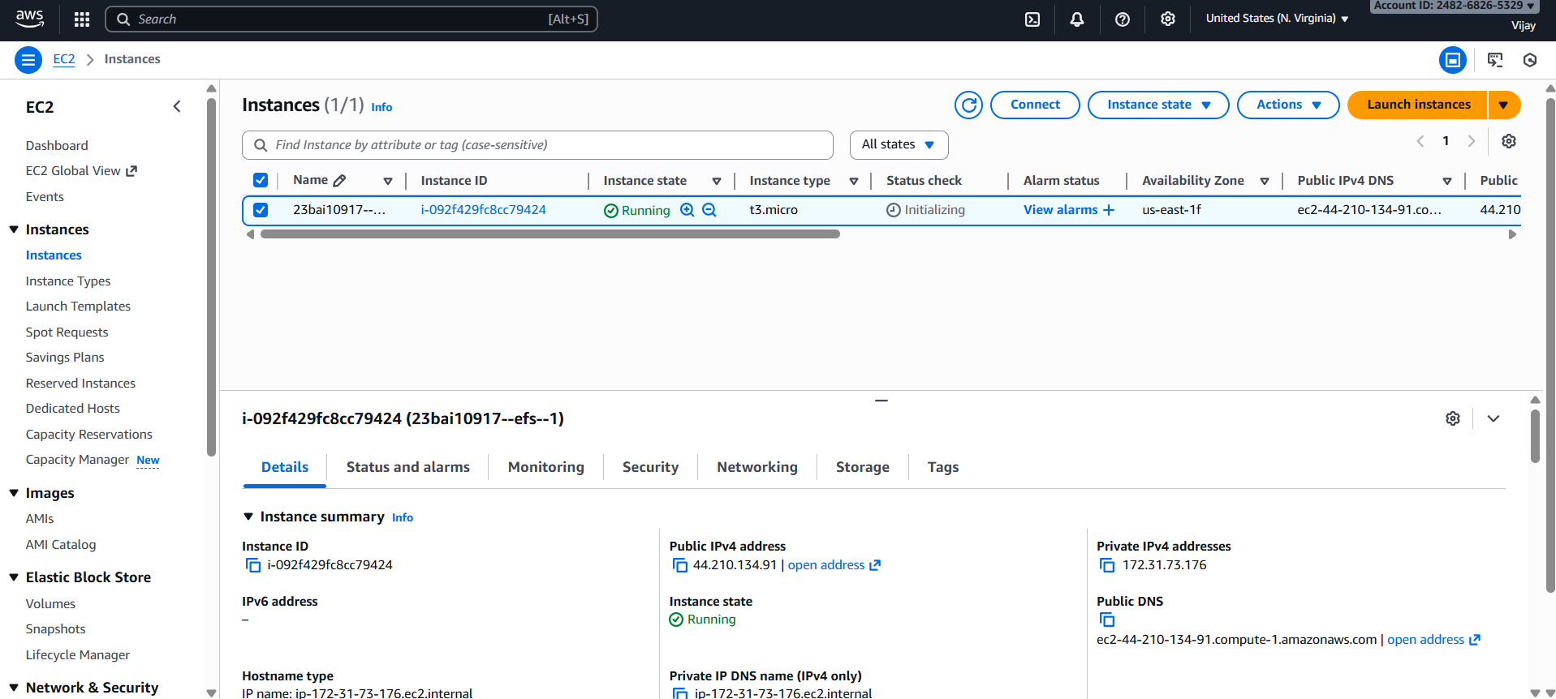

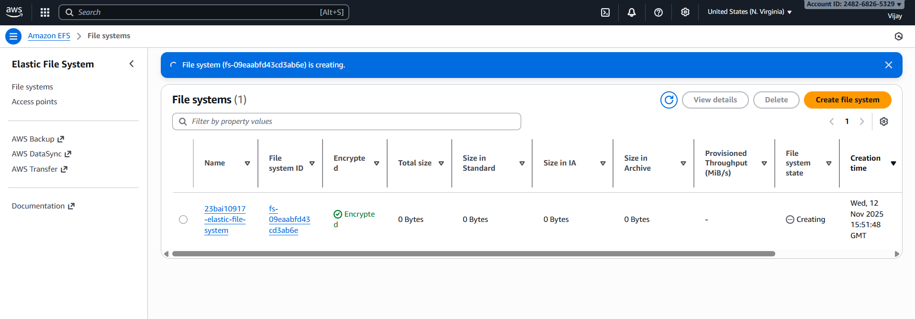

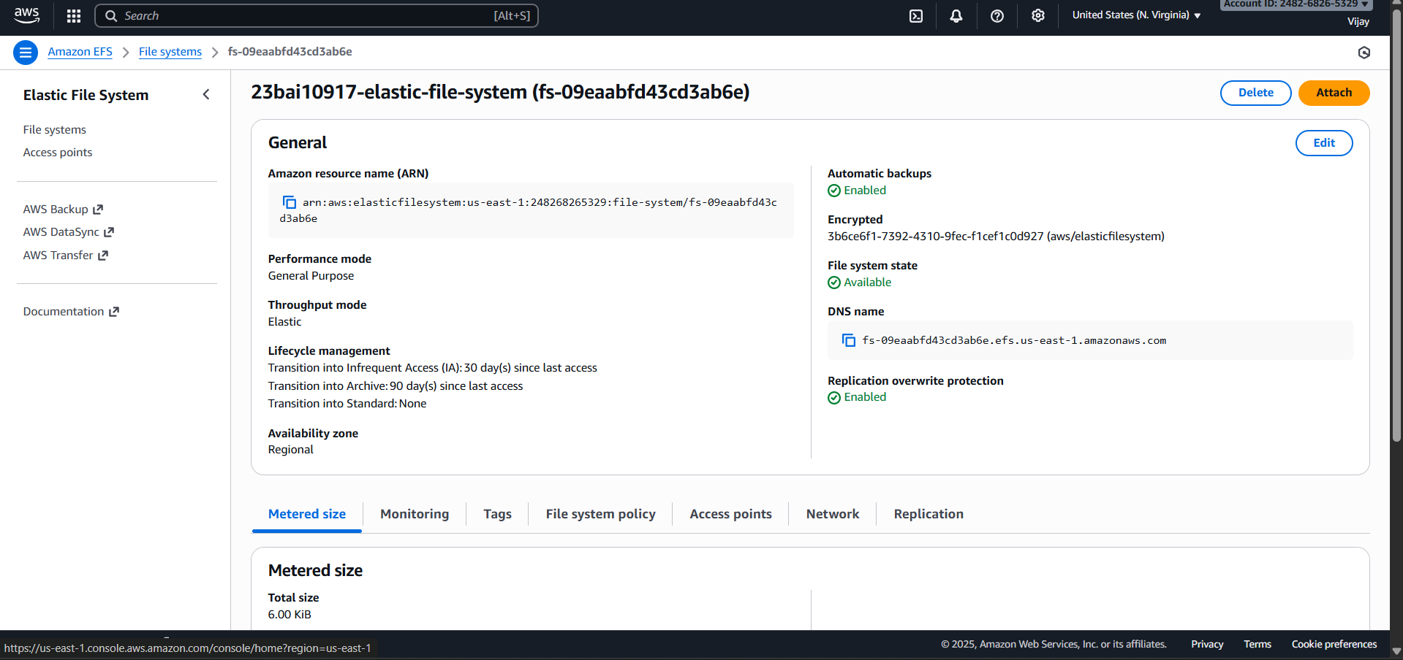

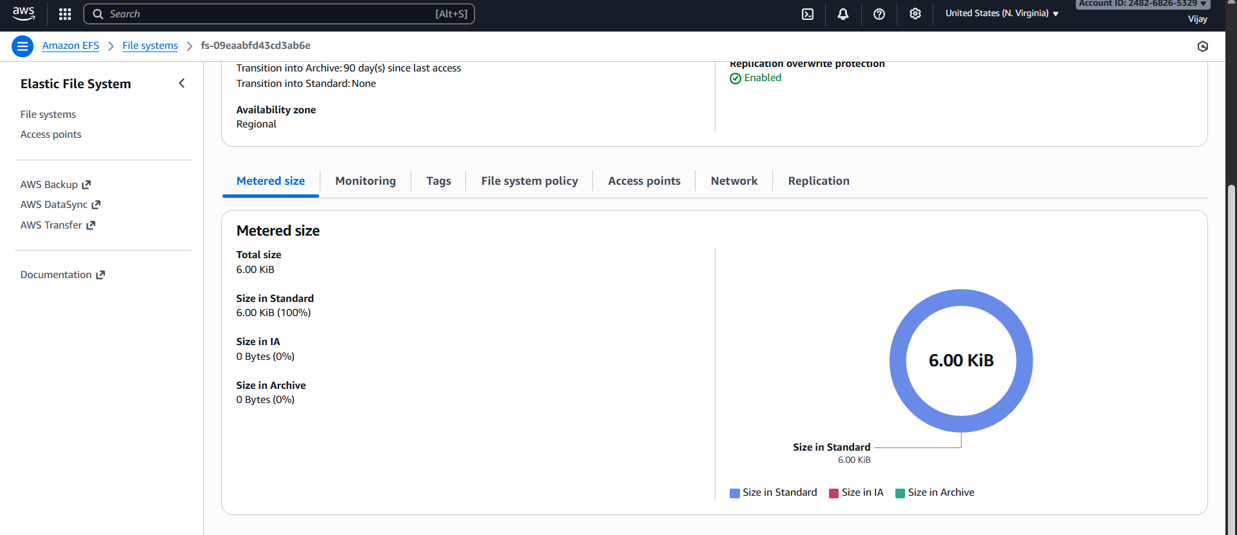

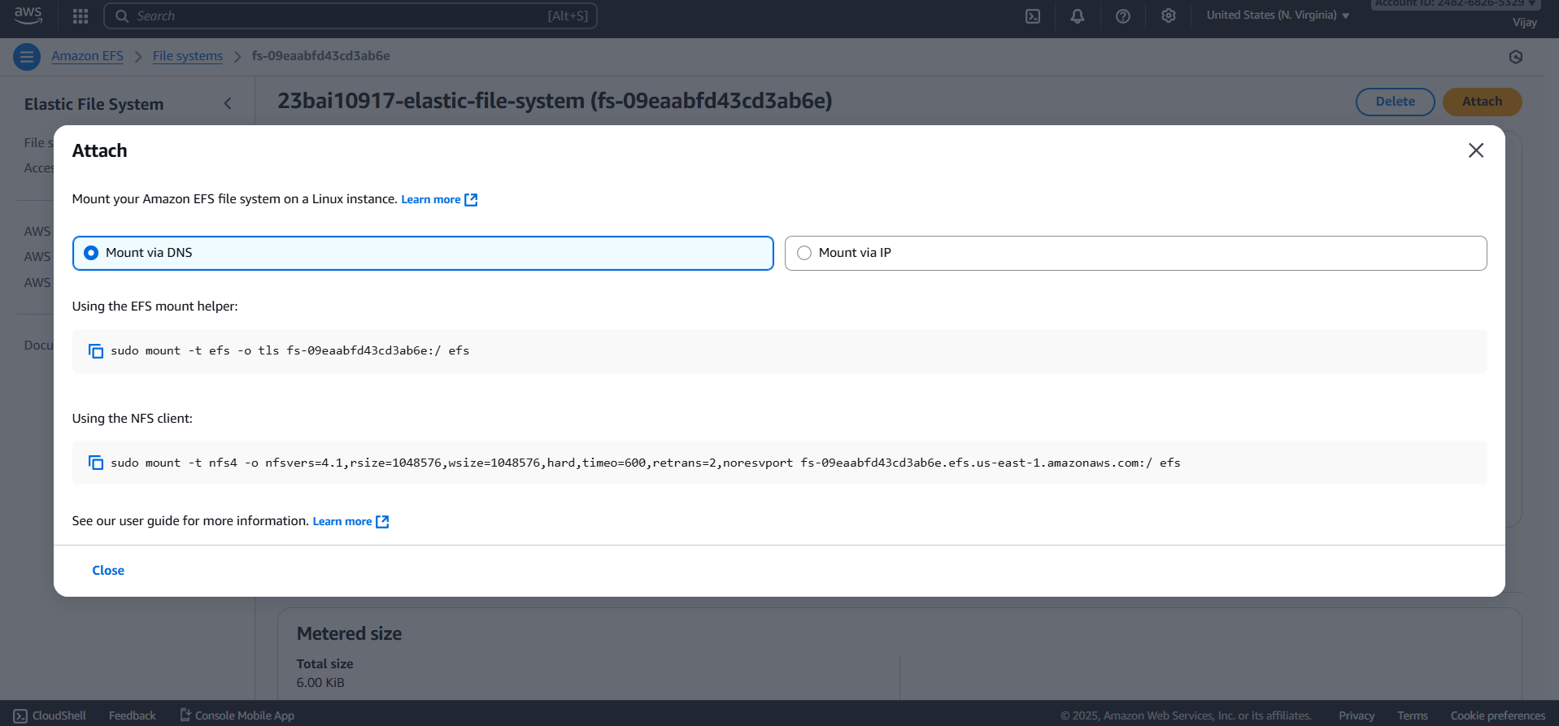

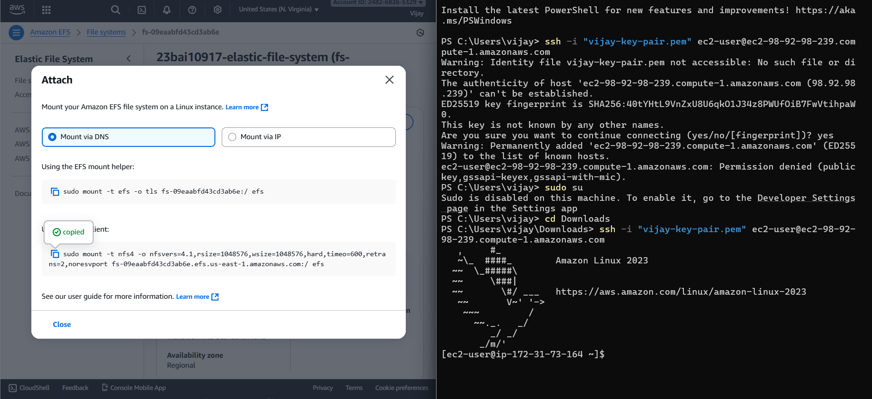

RESULT

The EFS file system will be successfully mounted to the EC2 instance, verified by the presence of the EFS network volume when running the
df -hT command. This result confirms that the storage is decoupled from the compute instance, allowing files written to the mounted directory to be immediately accessible, scalable, and persistent across all other EC2 instances securely mounted to the same EFS.

EXP.NO: 05 | Create and configure CloudFront distributions to accelerate the delivery of their web content, improve  website performance, and enhance user experience
DATE: 13-11-25

AIM

To Create and configure CloudFront distributions to accelerate the delivery of their web content, improve website performance, and enhance user experience.

PROCEDURE

- Select Distribution Type: Navigate to the CloudFront console and choose "Create Distribution," selecting the appropriate delivery method (usually Web for website content).

- Define Origin: Specify the Origin Domain Name (e.g., your S3 bucket endpoint or Load Balancer DNS for EC2), set a unique Origin ID, and configure an Origin Access Control (OAC) to restrict direct public access to the Origin.

- Configure Cache Behavior: Define the path patterns (e.g., Default (*)) and set the Viewer Protocol Policy (e.g., Redirect HTTP to HTTPS) and Allowed HTTP Methods (e.g., GET, HEAD).

- Set Caching Policy: Choose or create a Cache Policy to control how long content stays in the edge locations (Time-To-Live or TTL) and which request headers, cookies, or query strings are forwarded to the Origin.

- Distribution Settings: Specify the Price Class (geographic regions to serve), the Alternate Domain Names (CNAMEs) for your custom domain, and the Custom SSL Certificate for secure connections.

- Create and Wait: Review all settings and click "Create Distribution." Wait for the distribution's status to change from InProgress to Deployed (this typically takes 15–30 minutes).

- Update DNS: Once deployed, update your domain's DNS records by creating a CNAME record that points your custom domain name (e.g., www.example.com) to the new CloudFront Distribution Domain Name.

IMPLEMENTATION SCREENSHOT

Creating S3 bucket.

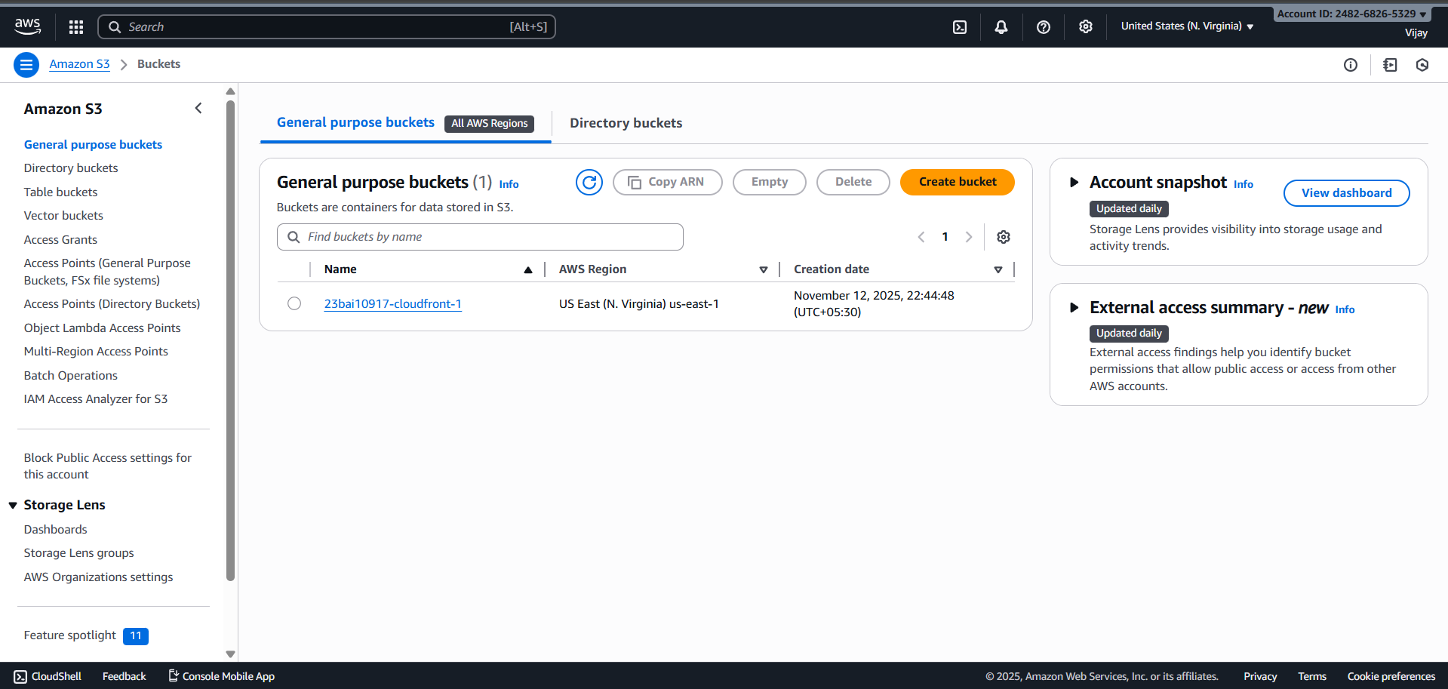

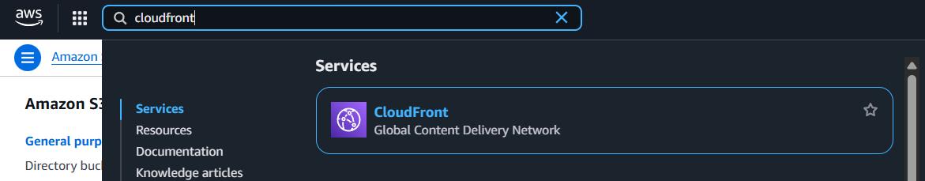

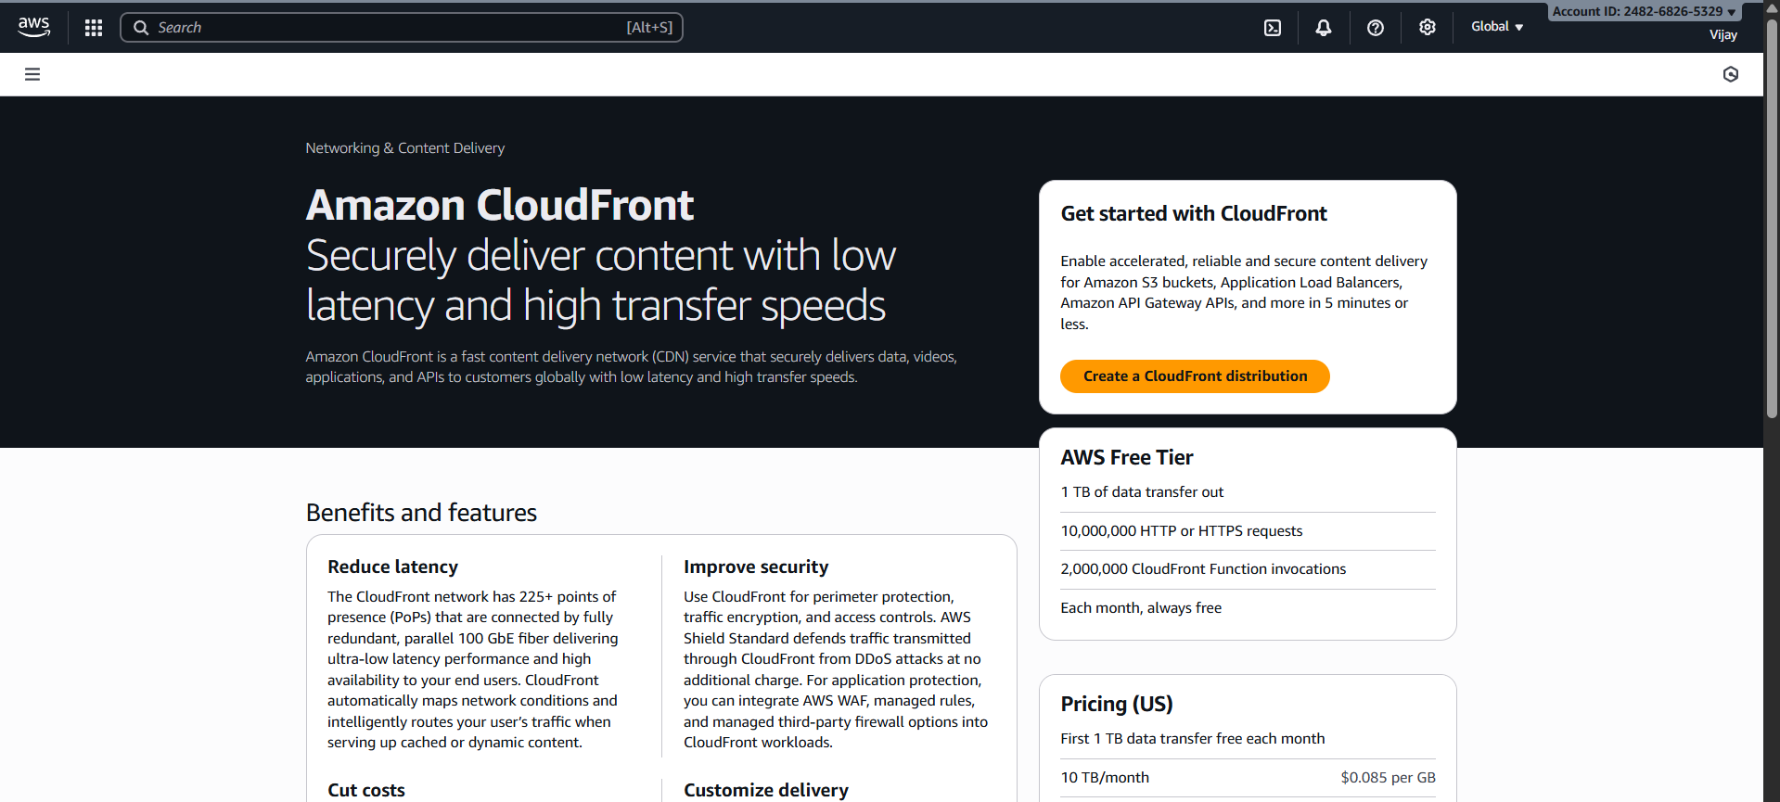

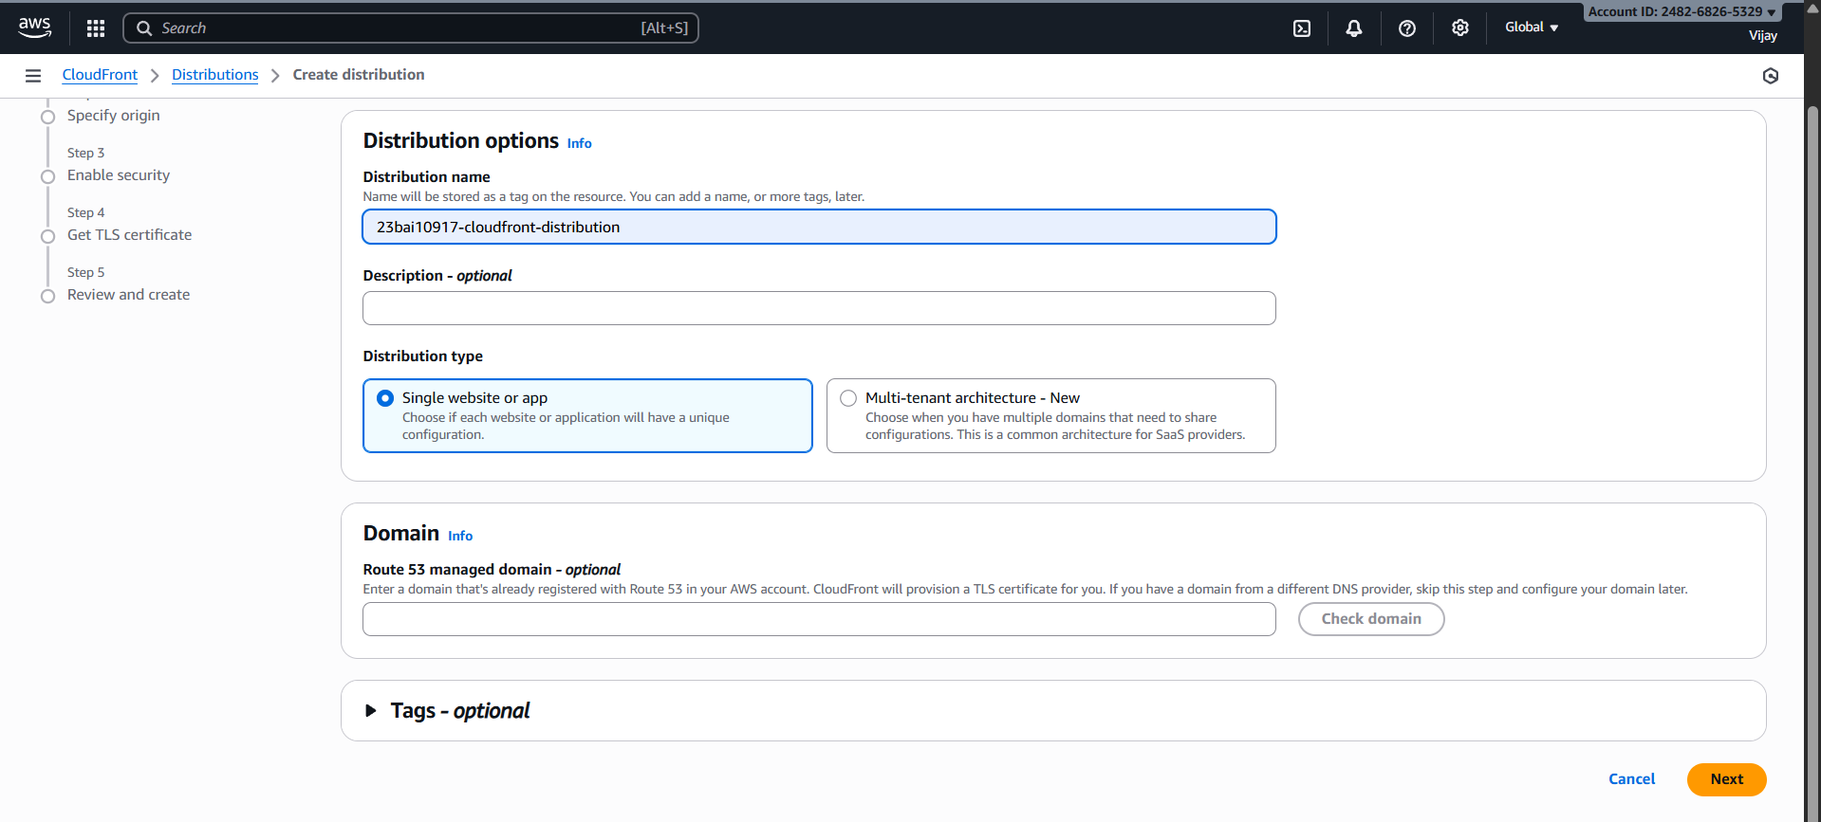

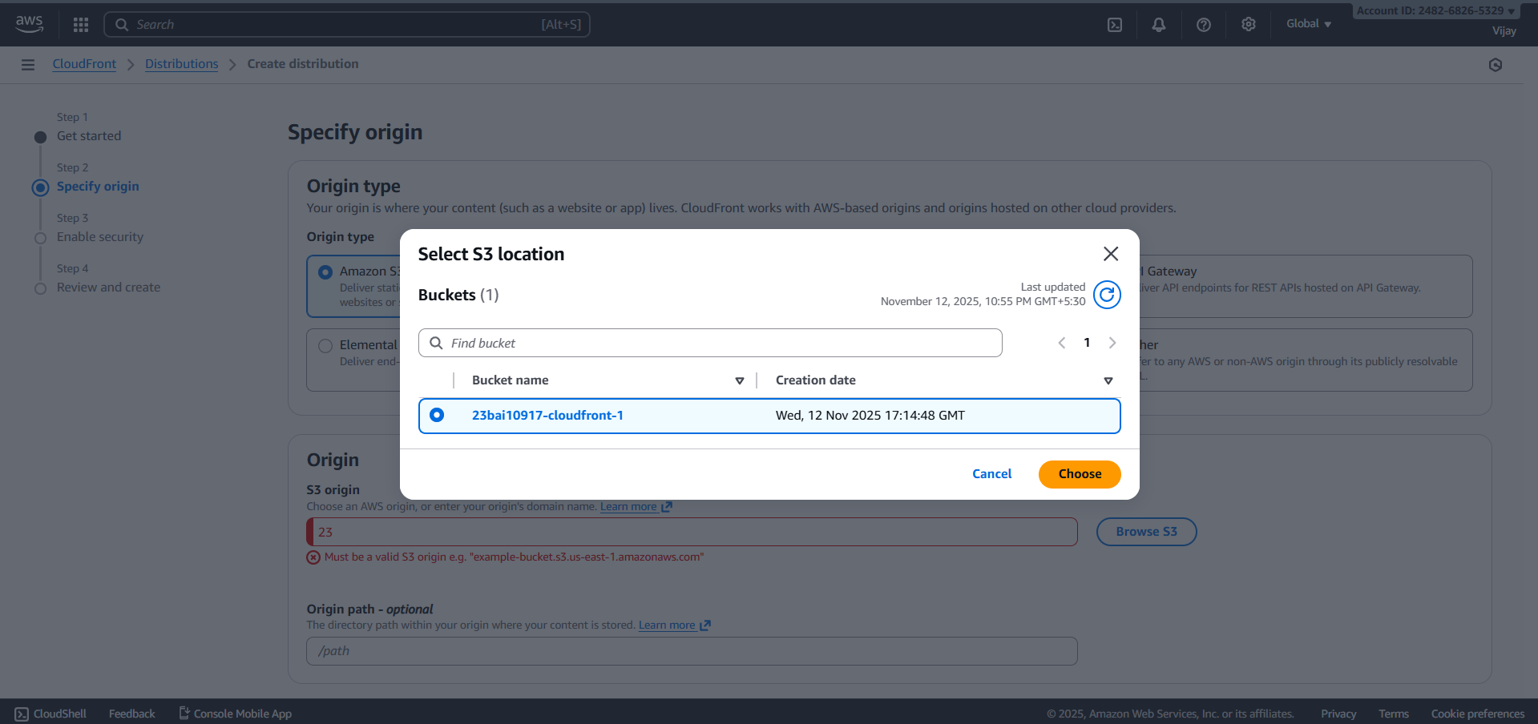

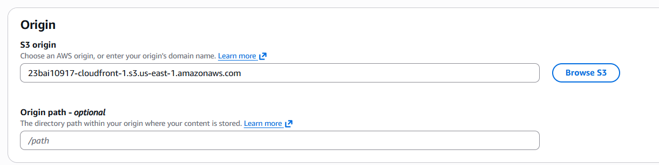

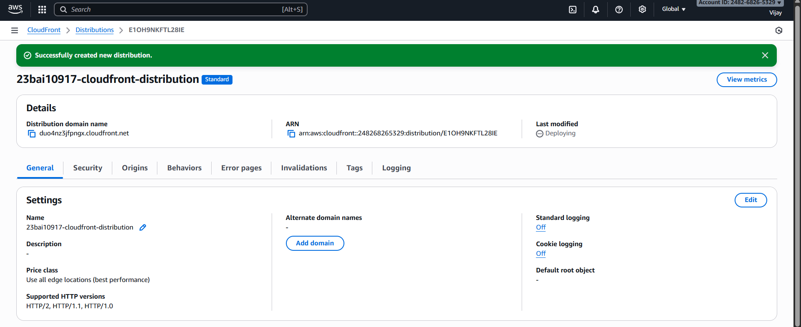

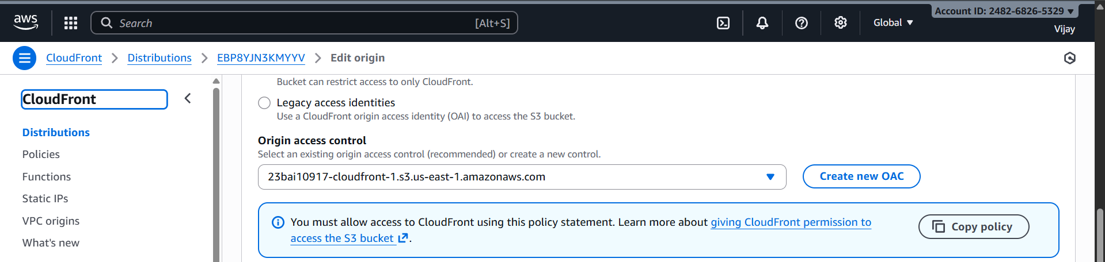

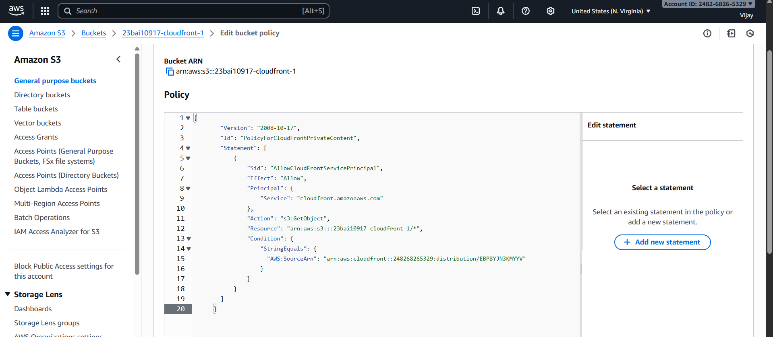

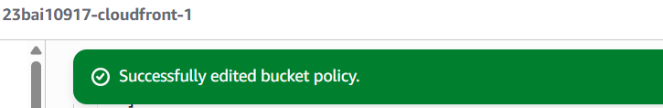

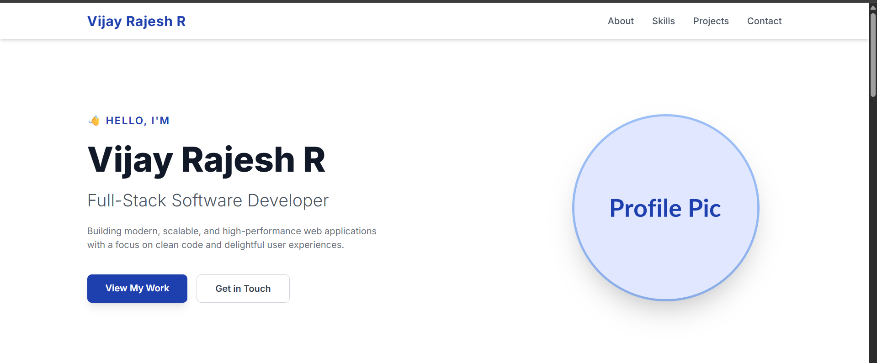

RESULT

Upon updating the DNS and successful propagation, website visitors accessing the custom domain will be automatically routed to the nearest CloudFront Edge Location, resulting in reduced latency, faster loading times, and a highly available content delivery experience. The distribution will effectively cache content, minimizing direct requests to the Origin and improving overall website performance and security.

EXP.NO: 06 | Create AWS Certificate Manager (ACM) for managing SSL/TLS certificates for secure communication  in AWS
DATE: 14-11-25

AIM

To request a public SSL/TLS certificate from AWS Certificate Manager (ACM), validate domain ownership using DNS records, and integrate the issued certificate with an Application Load Balancer (ALB) to enable secure HTTPS communication for a hosted application.

PROCEDURE

- Request an ACM Certificate: Navigate to the ACM console and choose Request a public certificate. Enter the desired fully qualified domain name (FQDN) (e.g., www.example-lab.com) and a wildcard domain (e.g., *.example-lab.com) for multi-subdomain support. Select the DNS validation method and click Request.
- Validate Domain Ownership (DNS): Once the certificate request is in Pending validation status, retrieve the CNAME record details provided by ACM. If the domain's DNS is hosted in Amazon Route 53, use the "Create records in Route 53" button to automatically add the required CNAME record to the public hosted zone. Wait for the certificate status to change to Issued.
- Provision Target EC2 Instance: Launch a simple EC2 instance running a web server (like Apache or NGINX) to serve plain HTTP content on port 80. Create a Target Group in EC2 to register this instance as a target.
- Create Application Load Balancer (ALB): Create an Application Load Balancer with listeners configured for both HTTP (port 80) and HTTPS (port 443). Configure the HTTP listener to redirect traffic to HTTPS.
- Integrate ACM Certificate with ALB: For the HTTPS (port 443) listener on the ALB, under Default SSL/TLS certificate, select Choose a certificate from ACM and choose the Issued certificate from Step 2. Select a secure Security policy (e.g., ELBSecurityPolicy-2016-08).
- Configure DNS Record for ALB: In Route 53, create an Alias record for the FQDN (www.example-lab.com) that points directly to the newly created ALB DNS name. This directs all public traffic for the domain to the Load Balancer.
- Final Validation: Access the domain in a web browser using HTTPS (e.g., https://www.example-lab.com). Verify that the browser displays a secure connection (lock icon) and confirm the certificate details show the ACM-issued certificate. Attempting to access the HTTP URL should automatically redirect to the secure HTTPS connection.

IMPLEMENTATION SCREENSHOT

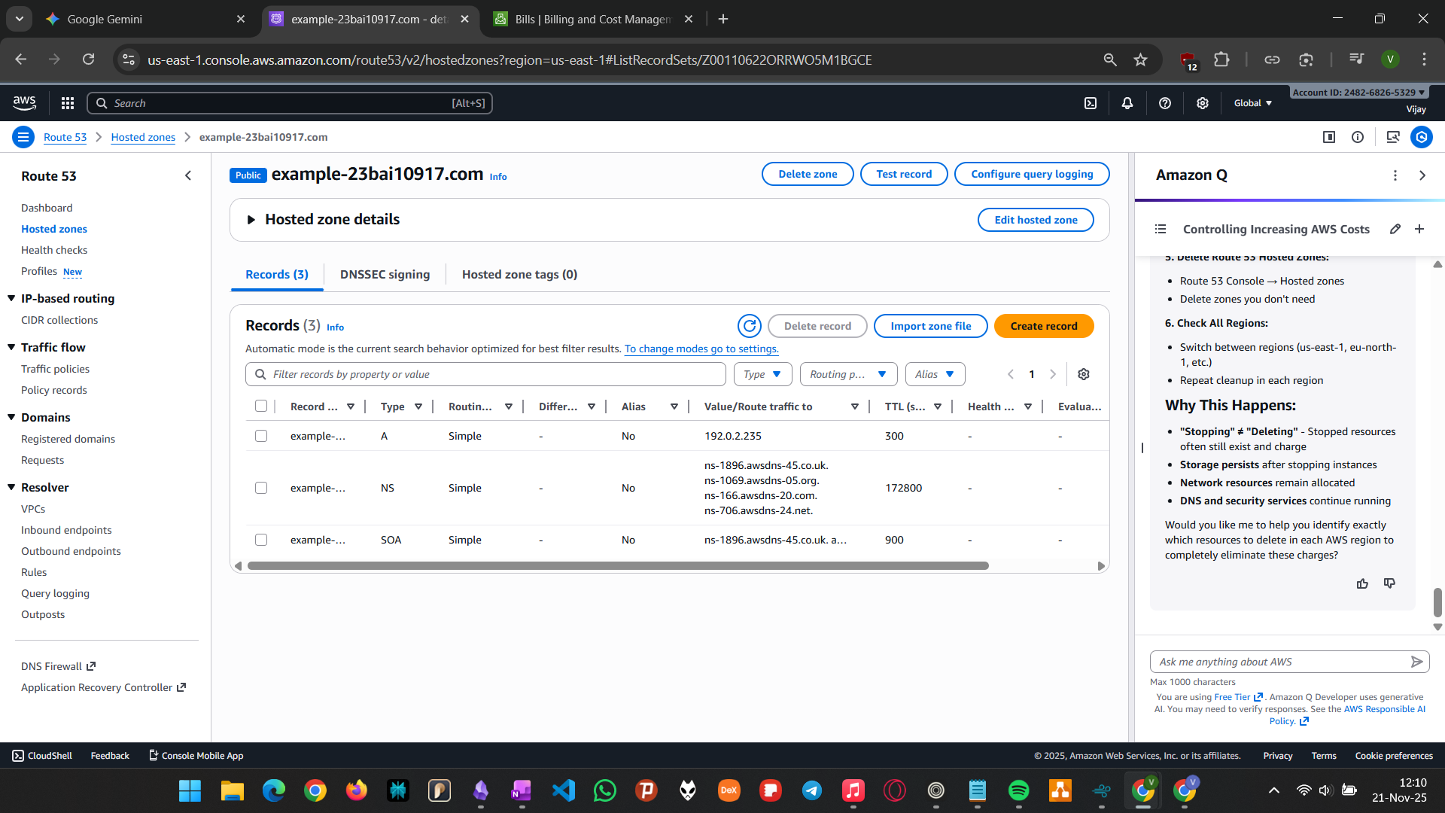
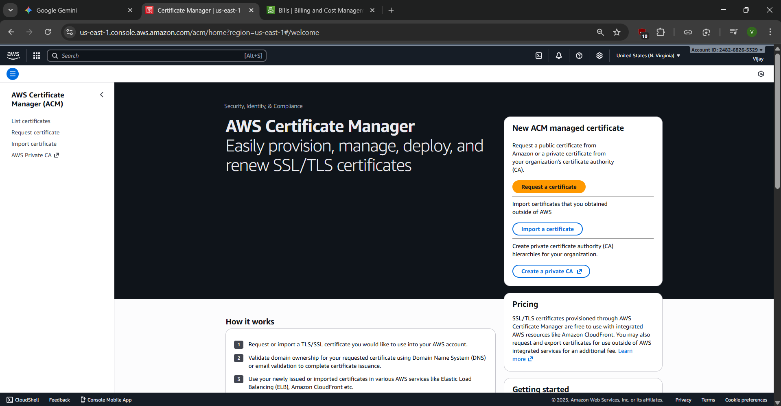

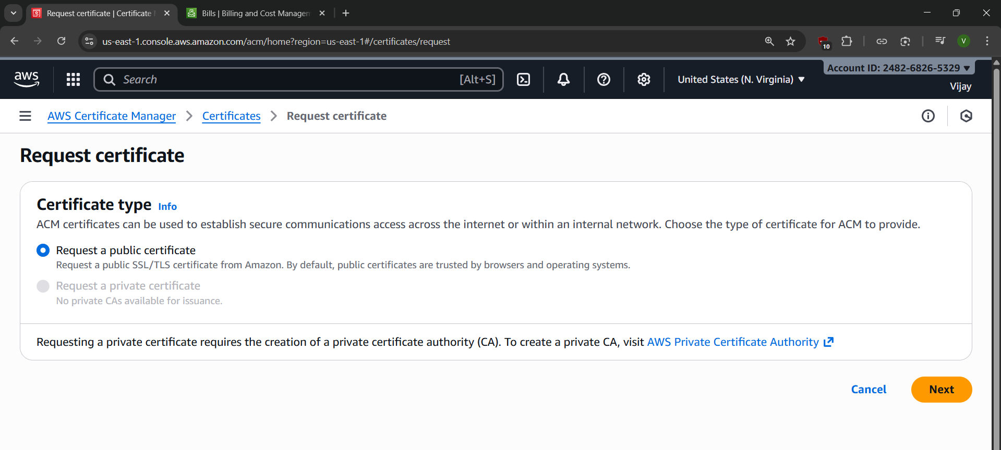
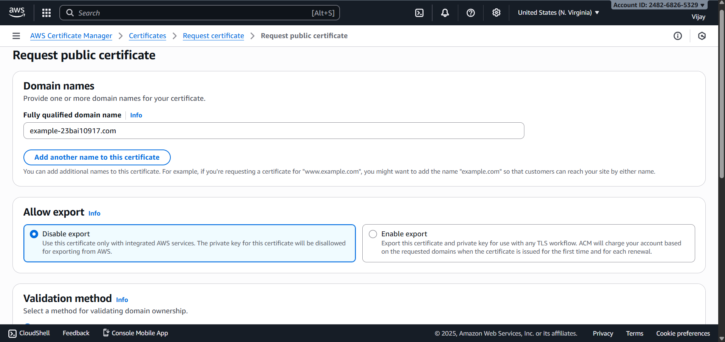

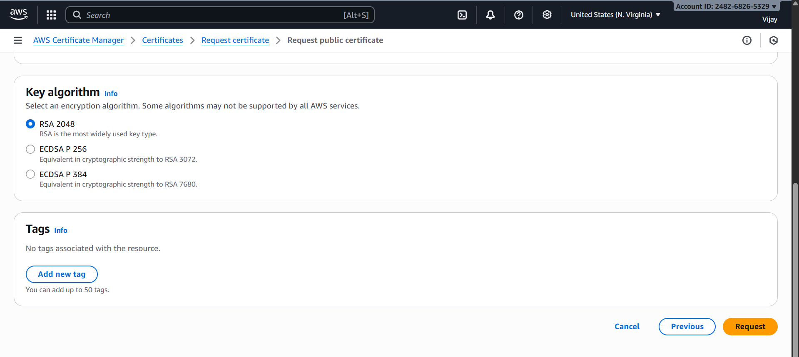
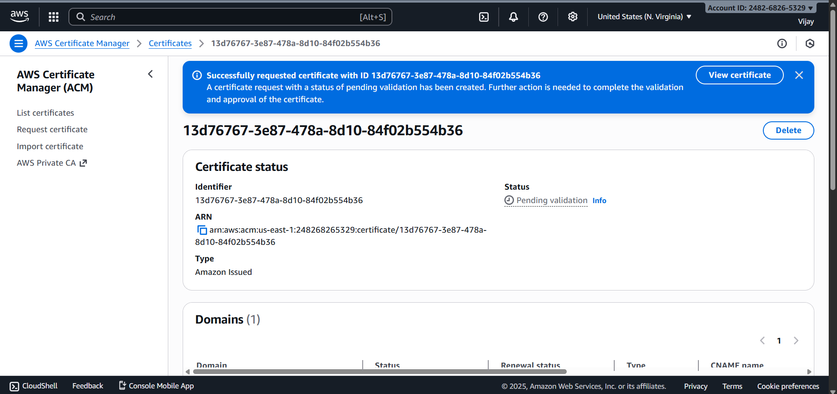

RESULT

The lab successfully demonstrated the automated provisioning of a publicly trusted SSL/TLS certificate via AWS Certificate Manager and its immediate integration with an Application Load Balancer. The certificate achieved the Issued status following DNS validation, and when integrated with the ALB, it enforced secure HTTPS termination for the web application, proving ACM's capability to manage secure communication with minimal manual intervention and ensuring managed certificate renewal.

EXP.NO: 07 | Create and manage customer master keys (CMKs), encrypt data using KMS, and integrate KMS with  AWS services for encryption
DATE: 14-11-25

AIM

To create and manage a Customer Managed Key (CMK) in AWS KMS, use this CMK to perform envelope encryption on data, and integrate the CMK with a primary AWS service (e.g., Amazon S3) to enforce server-side encryption.

PROCEDURE

- Create Customer Managed Key (CMK): Navigate to AWS KMS, select Customer managed keys, and choose Create key. Select Symmetric key type. Define the key administrators and key usage permissions (users/roles allowed to encrypt/decrypt data) via the key policy. Give the key a unique alias (e.g., Lab-S3-CMK) and description.
- Create Encrypted S3 Bucket: Navigate to Amazon S3 and create a new bucket (e.g., kms-encrypted-bucket-1234). In the Default encryption settings, select Server-Side Encryption with AWS Key Management Service key (SSE-KMS). Choose the CMK created in Step 1 (Lab-S3-CMK) from the dropdown list.
- Validate Default Encryption: Upload a new text file or image to the S3 bucket created in Step 2. Immediately check the object's Properties under the Server-side encryption section to confirm that it was automatically encrypted using SSE-KMS and the specific CMK ARN.
- Simulate Encryption Failure (Key Disable): Navigate back to the AWS KMS console, select the CMK (Lab-S3-CMK), and choose Disable from the Key actions menu. This renders the key unusable for cryptographic operations.
- Attempt Data Access with Disabled Key: Attempt to download the encrypted object from the S3 bucket. The download should fail with an "Access Denied" or decryption error, confirming that access to the encrypted data is directly tied to the availability and status of the CMK.
- Re-Enable and Verify Access: Navigate to AWS KMS, select the CMK (Lab-S3-CMK), and choose Enable from the Key actions menu. Wait a moment for the state to update.
- Final Decryption Validation: Attempt to download the encrypted object from the S3 bucket again. The download should now succeed, and the file should be fully readable, confirming successful key management and integration.

IMPLEMENTATION SCREENSHOT

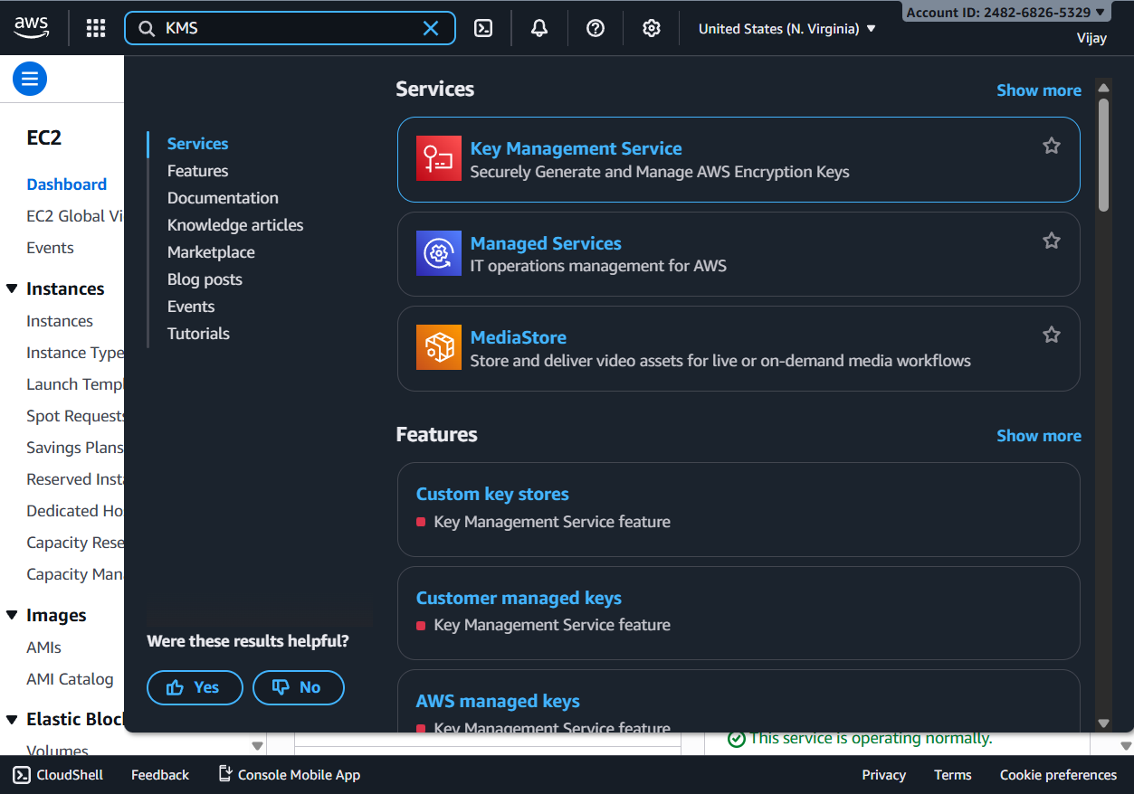

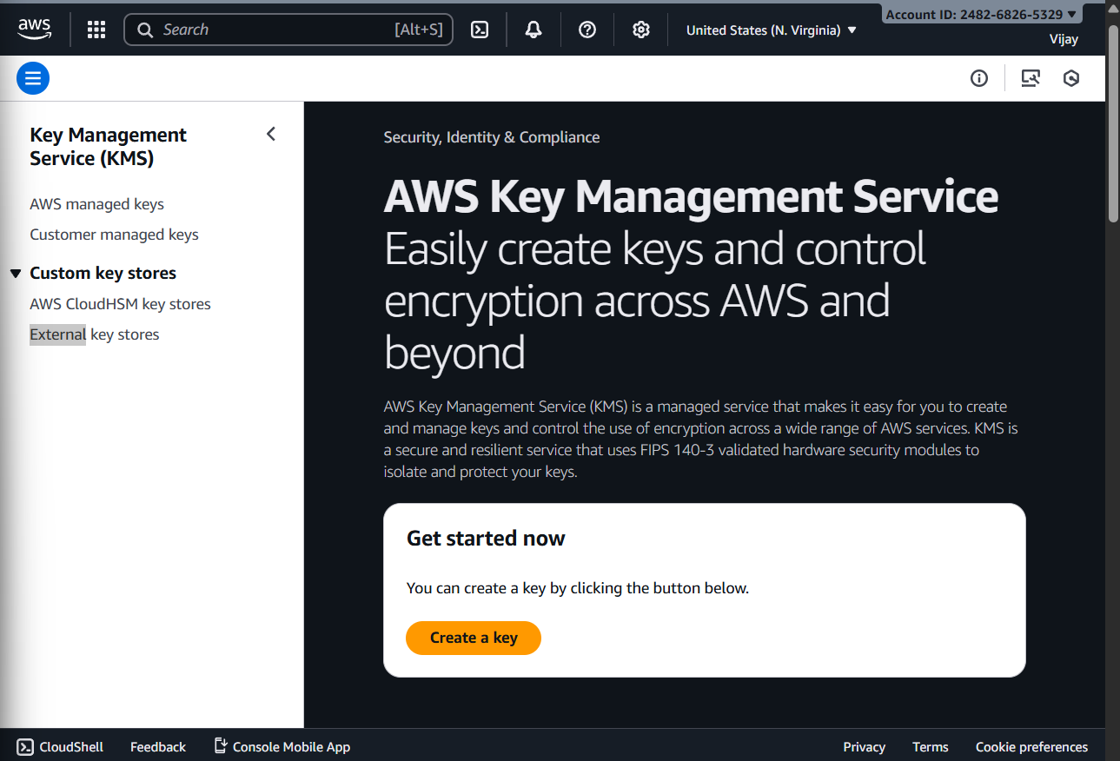

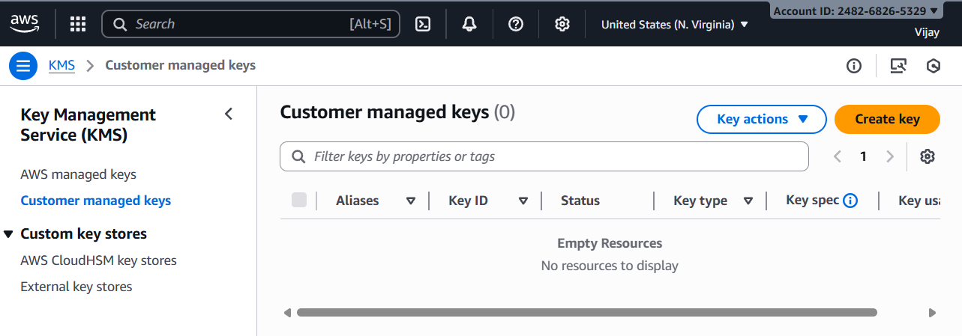

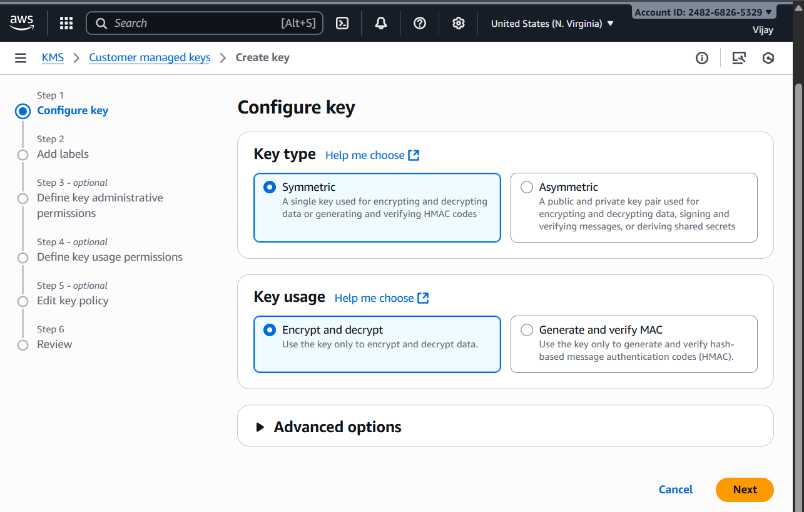

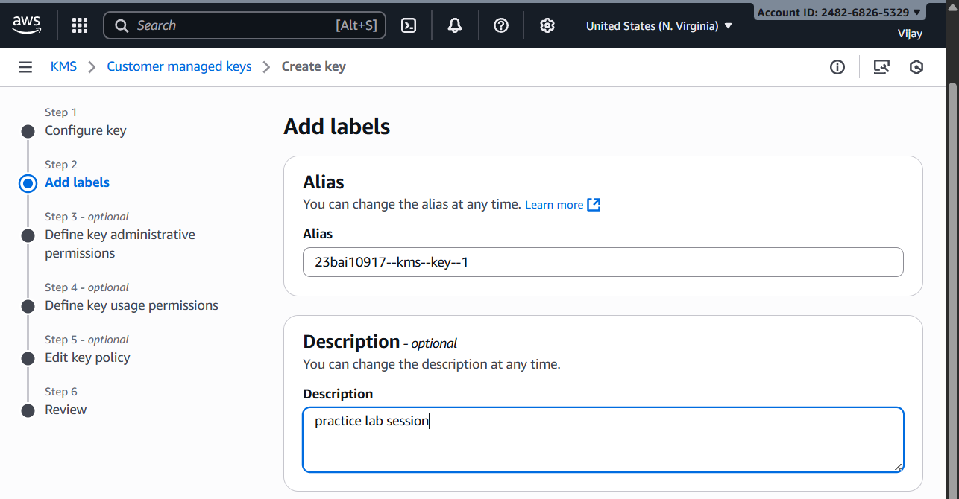

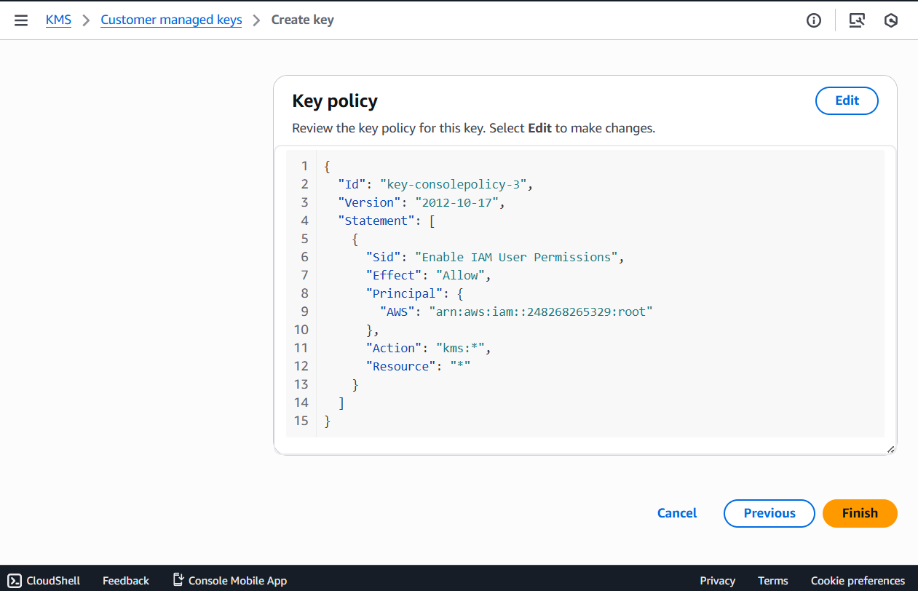

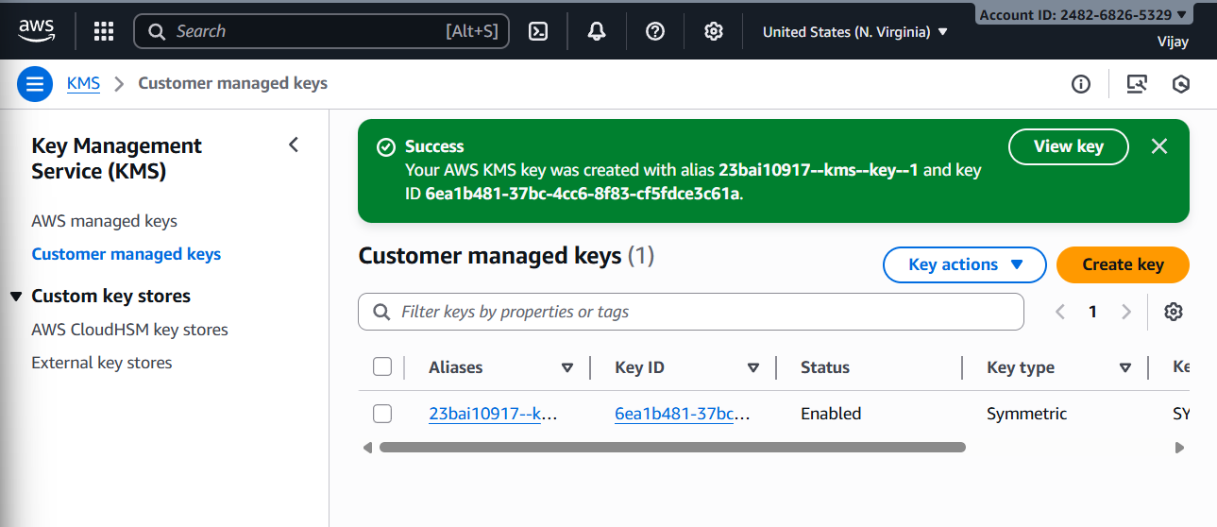

….

The key is created successfully…Now, integrating KMS with an AWS Service for encryption.
Configure an S3 bucket to use your newly created KMS key for Server-Side Encryption (SSE-KMS).

….

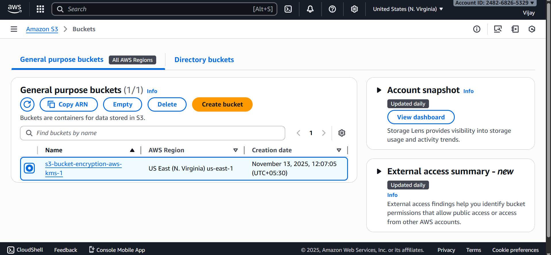

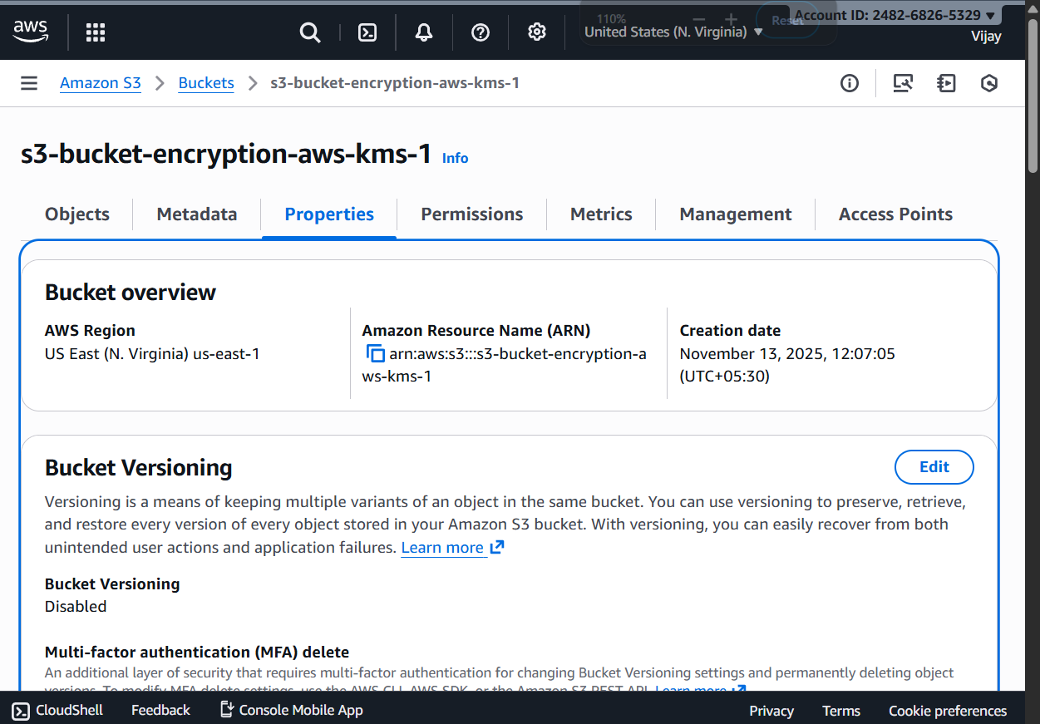

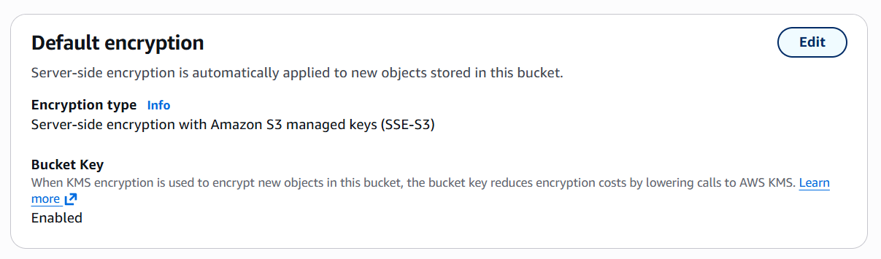
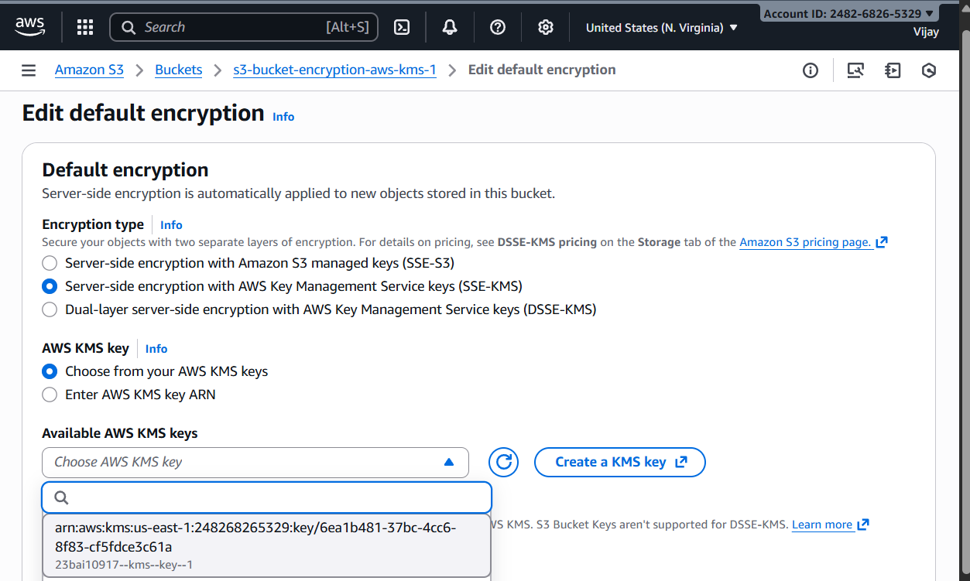

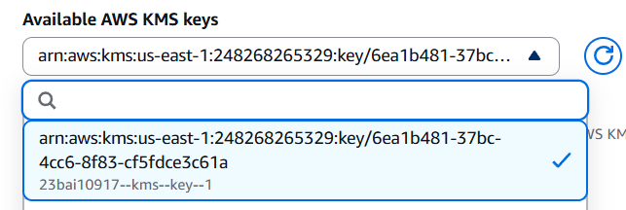

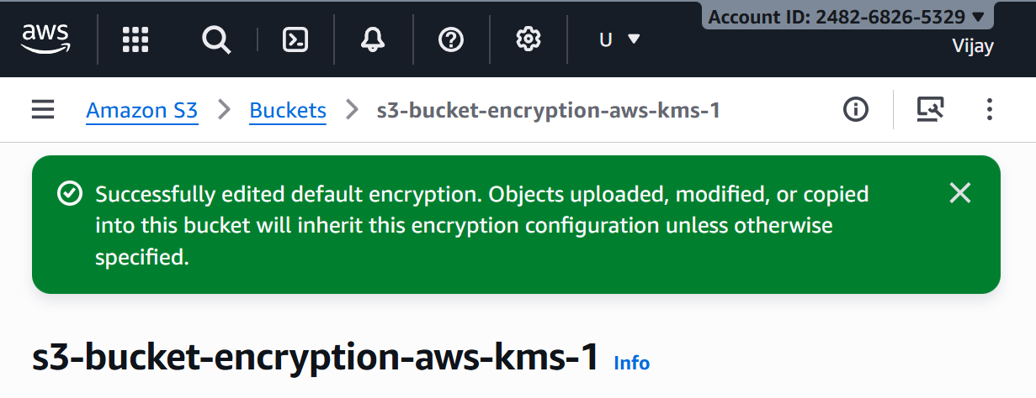

RESULT

The successful execution of the lab confirmed that the Customer Managed Key (CMK) was created and its usage permissions defined via the key policy. Integration with S3 was validated by observing automatic SSE-KMS encryption on all uploaded objects. Crucially, disabling the CMK instantly revoked access to the encrypted S3 objects, and re-enabling the CMK immediately restored access, demonstrating the centralized control and granular security provided by AWS KMS over data encryption.

EXP.NO: 08 | Set up CloudWatch monitoring for AWS resources, create custom metrics and alarms, analyze logs, and  troubleshoot performance issues using CloudWatch
DATE: 14-11-25

AIM

To Set up CloudWatch monitoring for AWS resources, create custom metrics and alarms, analyze logs, and troubleshoot performance issues using CloudWatch

PROCEDURE

- Provision and Instrument AWS Resource
- Launch an EC2 instance (e.g., t2.micro) and ensure detailed monitoring is enabled. For metrics beyond the basic 5-minute interval (like memory usage or disk utilization), install and configure the CloudWatch Agent on the instance. The agent will also be used to collect log files.
- Create Custom Metrics
- Using either the CloudWatch Agent configuration (for system metrics like memory/disk) or by creating Metric Filters in CloudWatch Logs, define a custom metric. For a Metric Filter, search the logs for a specific pattern (e.g., "ERROR" or a specific response time) and assign it a metric value (e.g., count the occurrences of "ERROR").
- Set Up Alarms and Notifications
- Create a CloudWatch Alarm based on one of the collected metrics. Choose a standard metric (e.g., EC2 CPU Utilization) or your newly created custom metric. Define the threshold (e.g., CPU Utilization $> 70\%$ for 5 minutes). Configure an SNS Topic to send an email notification when the alarm state changes to ALARM.
- Simulate Performance Issue
- On the EC2 instance, execute a command or script (e.g., using the stress utility for Linux) to deliberately increase the monitored metric (e.g., 100% CPU utilization). This action is intended to breach the alarm threshold and generate logs.
- Monitor the CloudWatch Metrics graph for the resource to observe the increase in the metric and verify that the alarm state transitions to ALARM. Confirm that the configured SNS notification is received. Stop the performance simulation to see the metric return to normal.
- Navigate to CloudWatch Logs Insights. Select the log group configured in Step 2. Execute a query to filter and analyze the logs generated during the performance issue (e.g., search for errors, count requests, or calculate average latency). Use the log data to identify the root cause of the simulated performance issue.

IMPLEMENTATION SCREENSHOT

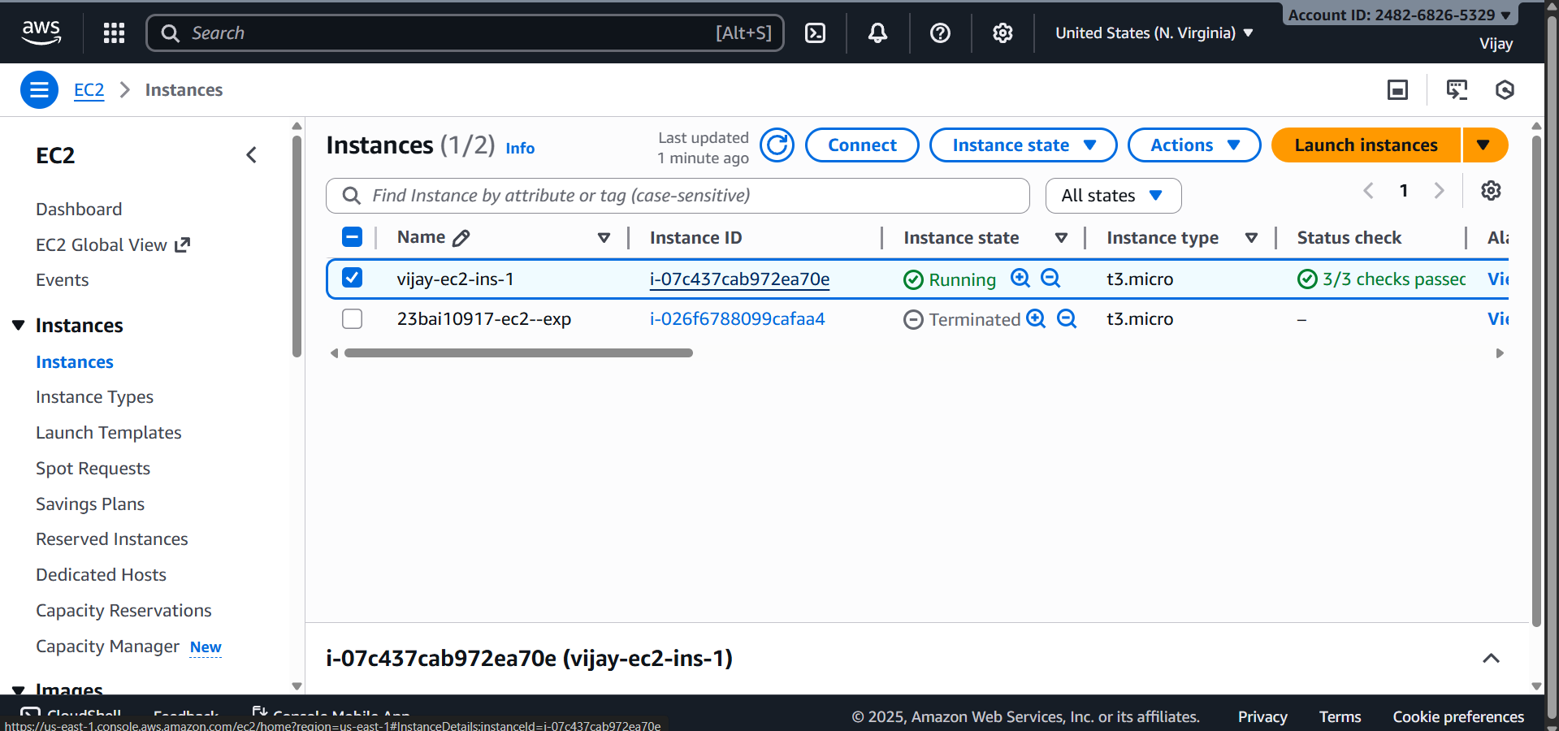

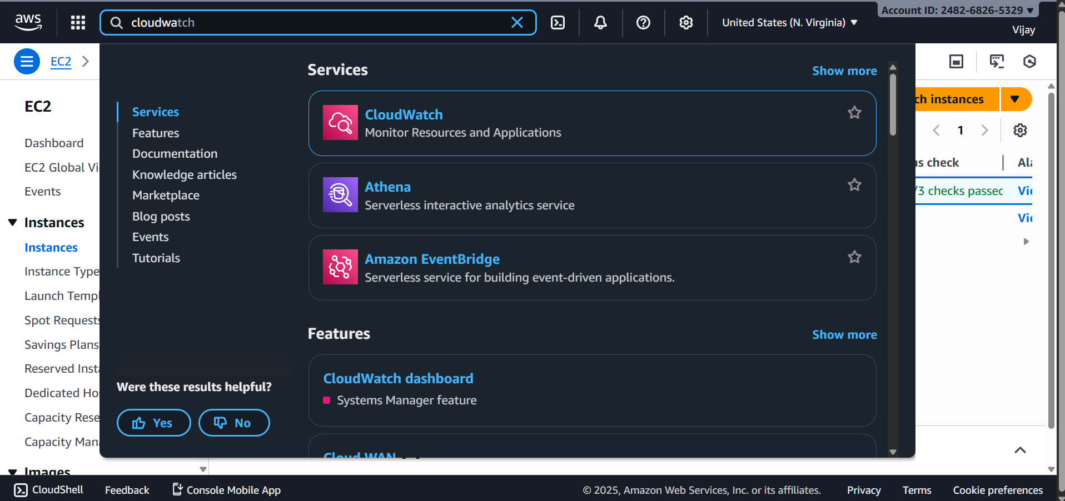

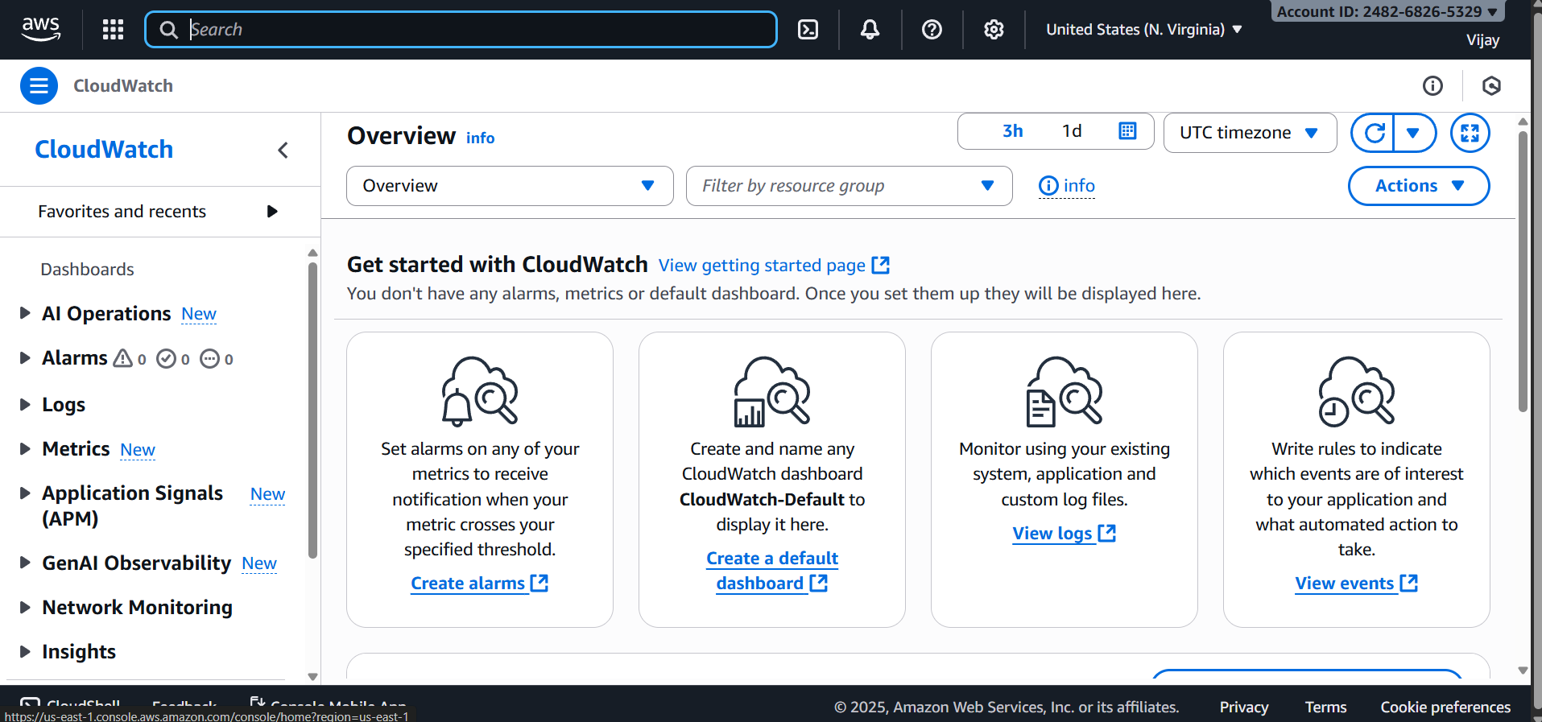

Alarms & Metrics

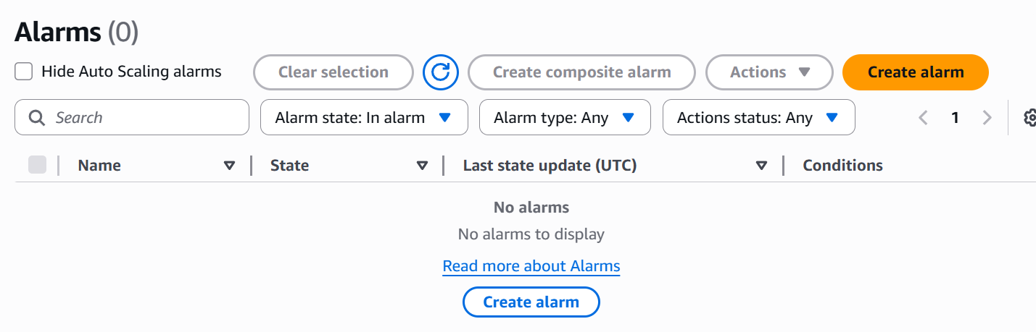

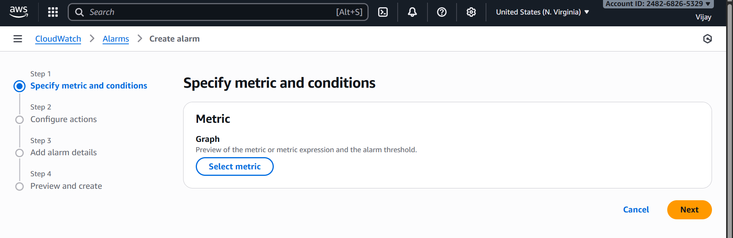

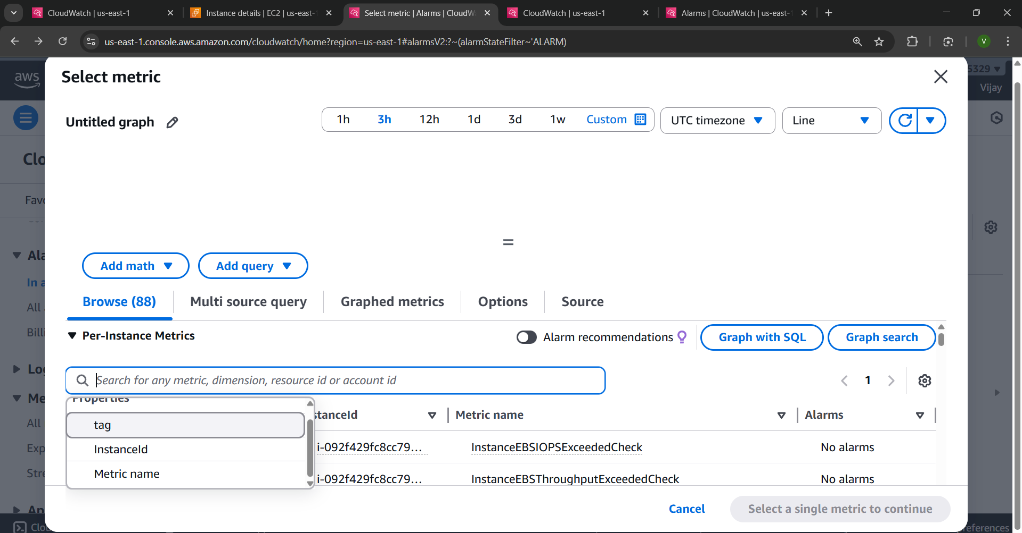

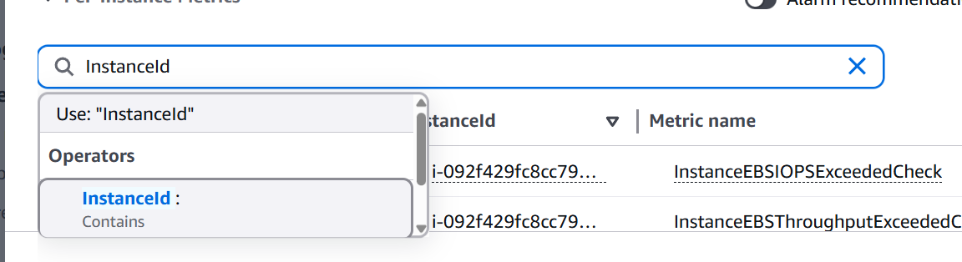

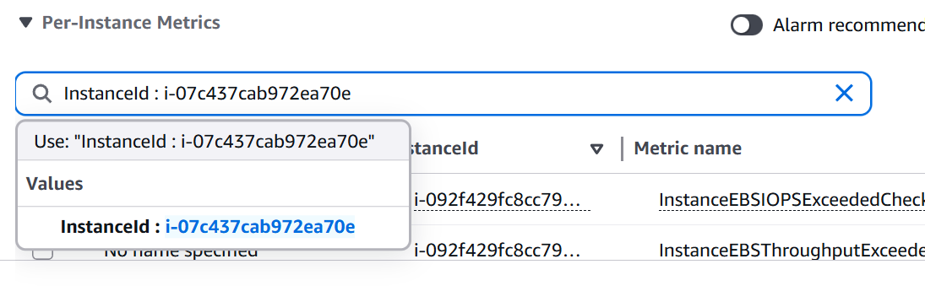
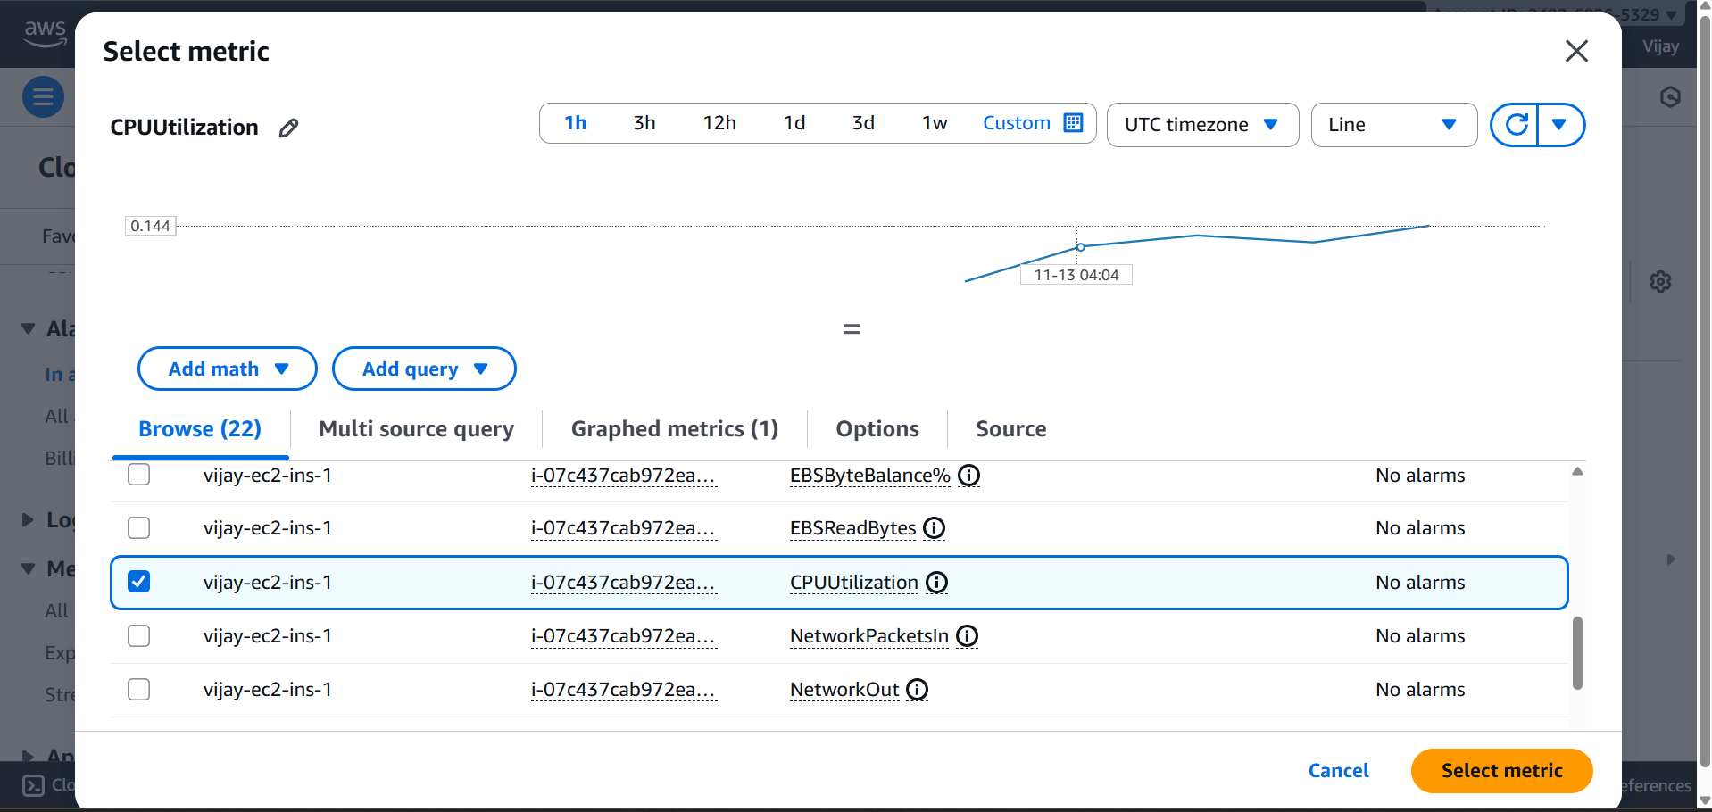

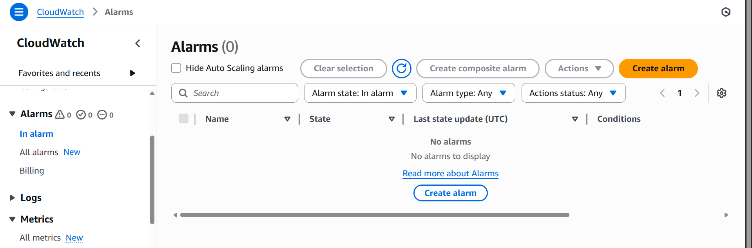

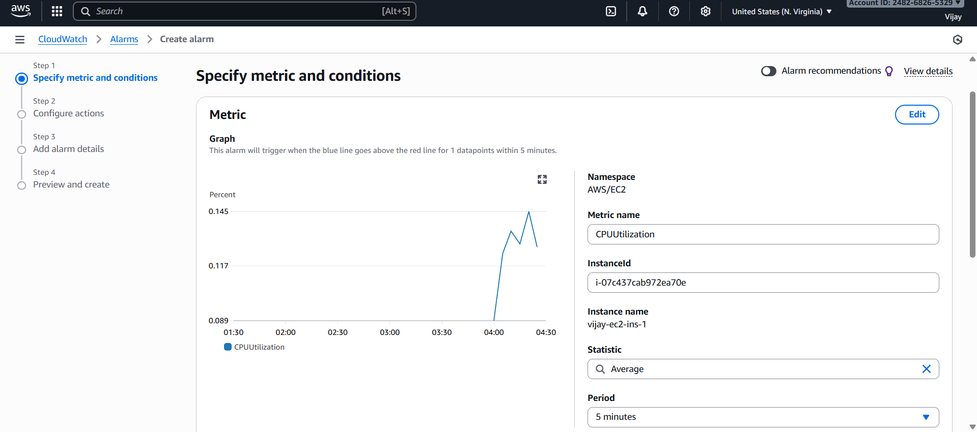
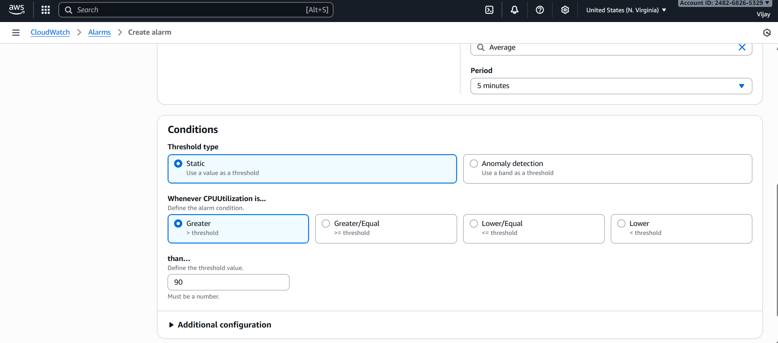

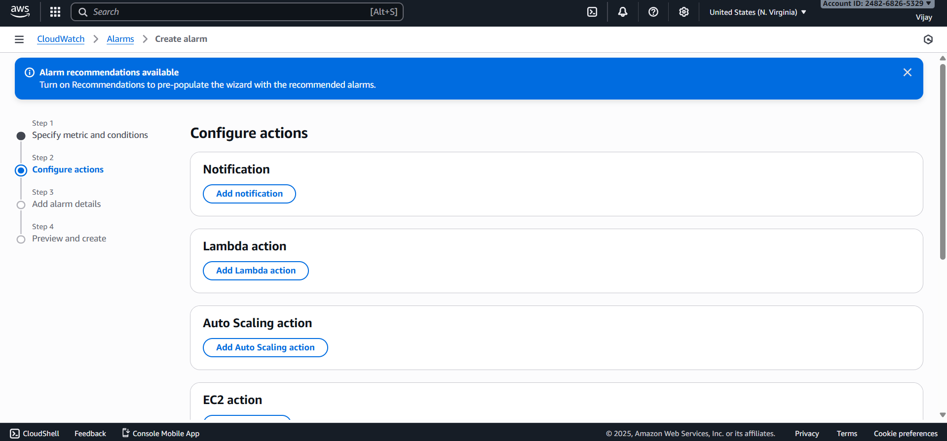

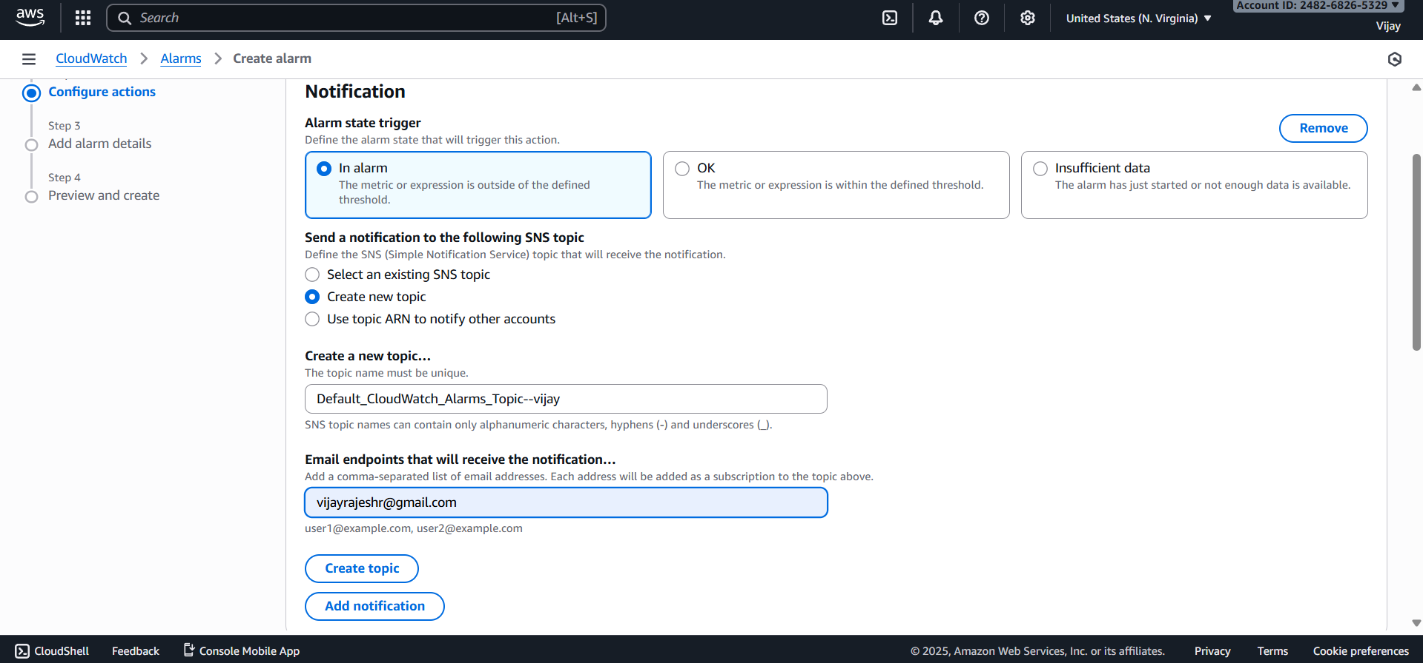

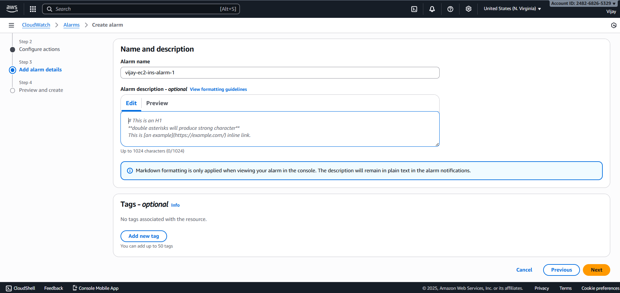

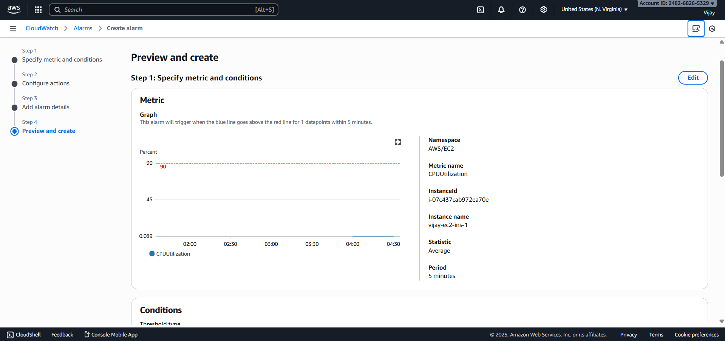

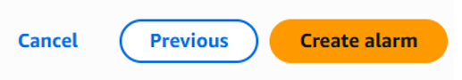

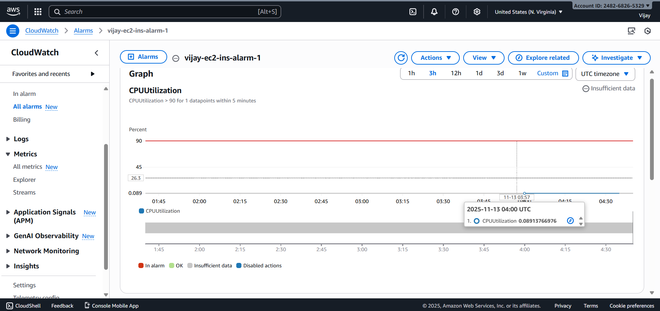

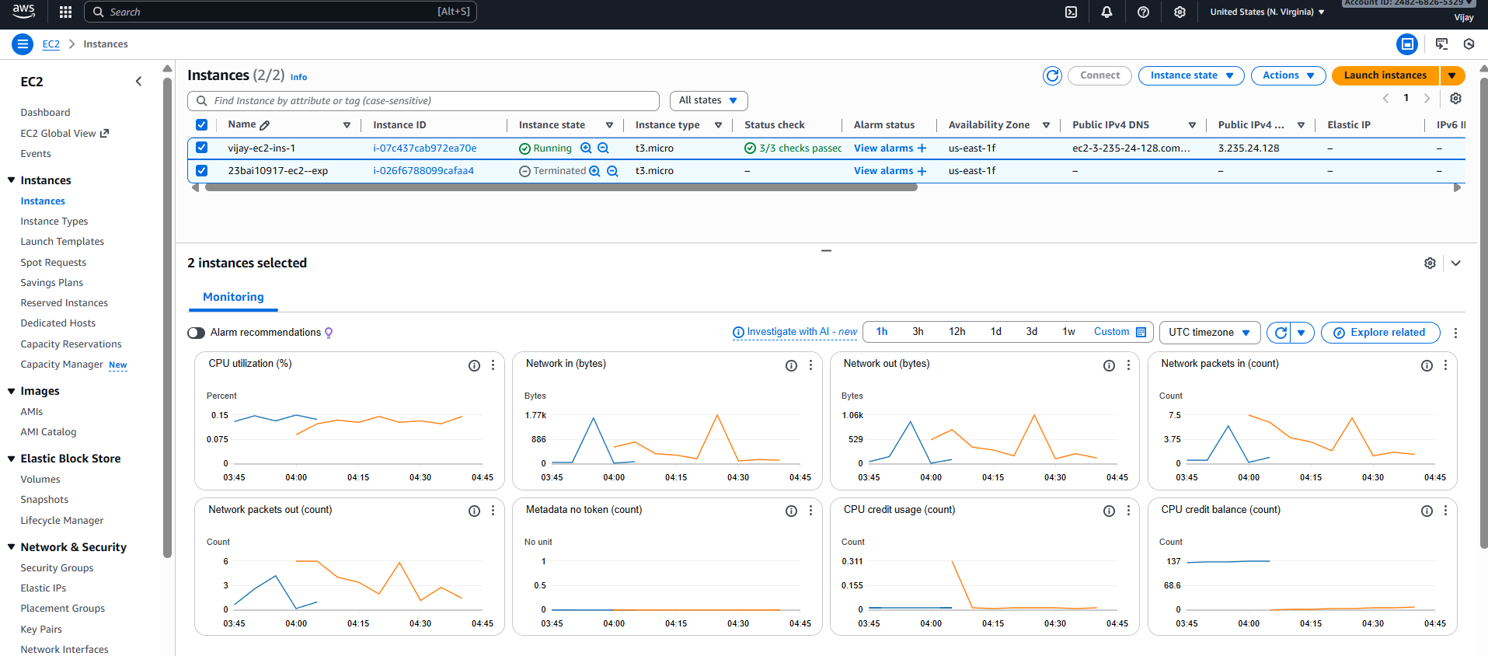

RESULT

The successful execution of the CloudWatch lab demonstrated the ability to collect and visualize metrics (CPU, Custom Metrics), confirm alarm triggering via SNS notification upon threshold breach, and utilize CloudWatch Logs Insights for querying log data to effectively troubleshoot and identify the root cause of the simulated performance issue.

